First page after clicking personal link:

Welcome back!

We are interested in how your vaping may or may not change over time. The questions will be very similar to the previous survey(s) and photos will be requested again. We recommend finding your most used device and liquid from the past seven days in advance.

We also recommend taking the survey on your mobile device to make photo uploading easier. Submitting downloaded photos from the internet will result in your disqualification.

New page:

Before we begin, would you like to review the consent form again? [var: view_consent_f]
  - Yes…skip to page with consent form
  - No…skip to page inquiring about gift code delivery

New page:

[Display consent form]

[If view_consent_f is ‘1’] Would you like to proceed to the survey? [var: proceed_f]
- Yes…skip to page inquiring about gift code delivery
- No…skip to page notifying participant that the link will remain active until end of the wave

[If proceed_f is ‘b’] [End]

New page [if Rybbon is used]:

Our team will [text/email/text or email] your $10 Amazon gift code after confirming your survey submission is valid and you will have one year to redeem the gift code. We must provide your name and email address to our gift code vendor, but they will not use your information for any purpose other than to provide your gift code. If you have any questions, please email vaper@vcu.edu or call us at 1-800-304-9402.

New page:

MESSAGE FOR IRB ONLY: Information displayed on this page is subject to change based on what is technically possible within REDCap. The essence of the information collected will remain the same.

[Display current contact information]

[If proceed_f is ‘a’ or view_consent_f is ‘b’] Do you wish to update any of your contact information? [var: contactupdate_f]
- Yes…next question
- No… skip to page with disqualification activities warning

[If contactupdate_f is ‘a’]: Which item(s) would you like to update? Select all that apply. [var: contactupdate2_f; checkbox]
- Email address [var: contactupdate2_f___1]
- Cell phone number [contactupdate2_f___2]
- Current residential mailing address [contactupdate2_f___3]

[If contactupdate2_f is ‘a’]: Please enter your updated email address: [var: email_f; email]
- Open ended response

[If contactupdate2_f is ‘b’]: Please enter your updated cell phone number: [var: cellphone_f; phone]
- Open ended response

[If contactupdate2_f is ‘c’]: Please enter your updated residential mailing address:

[If contactupdate2_f is ‘c’]: Address Line 1: [var: address_1_f]

[If contactupdate2_f is ‘c’]: Address Line 2: [var: address_2_f]

[If contactupdate2_f is ‘c’]: City [var: city_f]

[If contactupdate2_f is ‘c’]: State [var: state_f; dropdown]
- Alabama
- Alaska
- Arizona
- Arkansas
- California
- Colorado
- Connecticut
- Delaware
- Florida
- Georgia
- Hawaii
- Idaho
- Illinois
- Indiana
- Iowa
- Kansas
- Kentucky
- Louisiana
- Maine
- Maryland
- Massachusetts
- Michigan
- Minnesota
- Mississippi
- Missouri
- Montana
- Nebraska
- Nevada
- New Hampshire
- New Jersey
- New Mexico
- New York
- North Carolina
- North Dakota
- Ohio
- Oklahoma
- Oregon
- Pennsylvania
- Rhode Island
- South Carolina
- South Dakota
- Tennessee
- Texas
- Utah
- Vermont
- Virginia
- Washington
- Washington, DC
- West Virginia
- Wisconsin
- Wyoming

[If contactupdate2_f is ‘c’]: Zip Code [var: zipcode_f; zipcode]

New page:

As a reminder, any perceived attempt to speed through the survey, take the survey more than once, or provide false or misleading information will result in your disqualification from the survey and forfeiture of any promised incentives.

New page:

Screening Questions:

The next questions are about e-cigarettes or vaping devices.

There are many types of e-cigarettes or vaping devices. All are battery powered and produce vapor instead of smoke. E-cigarettes or vaping devices can be bought as one-time, disposable products, whereas other devices are re-usable.

Some re-usable devices have a tank that can be refilled with e-liquid (also called e-juice, PG juice, and vape juice), THC and CBD concentrates (also called waxes, oils, shatter, and dabs), herbs such as marijuana, and other substances. Other re-usable devices have replaceable cartridges or pods that contain the vaporized substance. Some of these cartridges or pods may be pre-filled and discarded after use, whereas, other cartridges and pods may be refillable.

Disposable e-cigarettes, pre-filled cartridges or pods, and bottles with e-liquids/oils for refillable devices come in many different flavors. Some people customize their own flavor blends by mixing their own flavors or having a vape shop mix their flavors.

Some common brands include JUUL, SMOK, Kandypens, and Grenco Science.
Here are a few examples of e-cigarettes or vaping devices.

[DISPLAY ’Blu_1’; ‘NJOY_1’; ‘G6_1’; ‘VuseVibe_1’; ‘JUUL_1’; ‘Smok_1’; ‘InnokinDV_1’; ‘PuffBar_1’; and/or ‘VaporessoLuxeS_1’]

- Have you used an e-cigarette or vaping device to vape THC concentrates, such as waxes, oils, shatter, and/or dabs in the past 30 days? [var: vape_thc_p30_f]
  - Yes…next Q
  - No…skip to Q3

- [If vape_thc_p30_f is ‘a’] How many days in a typical week do you use an e-cigarette or vaping device to vape THC concentrates? [var: vape_thc_wk_f]
  - I do not use an e-cigarette or vaping device to vape THC concentrates in a typical week… next Q to further assess transition
  - 1 day… next Q
  - 2 days… next Q
  - 3 days… next Q
  - 4 days… next Q
  - 5 days…next Q
  - 6 days…next Q
  - 7 days…next Q

- Have you used an e-cigarette or vaping device to vape CBD concentrates, such as waxes, oils, shatter, and/or dabs, in the past 30 days? [var: vape_cbd_p30_f]
  - Yes…next Q
  - No…skip to Q5

- [If vape_cbd_p30_f is ‘a’] How many days in a typical week do you use an e-cigarette or vaping device to vape CBD concentrates? [var: vape_cbd_wk_f]
  - I do not use an e-cigarette or vaping device to vape CBD concentrates in a typical week… next Q
  - 1 day… next Q
  - 2 days… next Q
  - 3 days… next Q
  - 4 days… next Q
  - 5 days…next Q
  - 6 days…next Q
  - 7 days…next Q

- Have you used an e-cigarette or vaping device to vape e-liquids with or without nicotine in the past 30 days? [var: ecig_p30_f]
  - Yes…next Q
  - No…skip to ineligible screen

- [If ecig_p30_f is ‘a’] How many days in a typical week do you use an e-cigarette or vaping device to vape e-liquids with or without nicotine? [var: ecig_wk_f]
  - I do not use an e-cigarette or vaping device to vape e-liquids with or without nicotine in a typical week…ineligible…skip to ineligible screen
  - 1 day…ineligible…skip to ineligible screen
  - 2 days…ineligible…skip to ineligible screen
  - 3 days…ineligible…skip to ineligible screen
  - 4 days…ineligible…skip to ineligible screen
  - 5 days…eligible
  - 6 days…eligible
  - 7 days…eligible

[If ecig_p30_f is 'b' or ecig_wk_f is ‘a', ‘b', ‘c', ‘d' or ‘e']: Thank you for your time. Unfortunately, you are not currently eligible to participate in this survey.

[If (ecig_p30_f is ‘a’) and (ecig_wk_f is 'f', 'g', or 'h')]: [Continue to thc_check_f]

Eligible users:

Q5: Yes
Q6: 5-7 days
Questionnaire:
Unless otherwise stated, all questions hereafter are in reference to e-cigarettes or vaping devices used to consume e-liquid (also called e-juice, PG juice, and vape juice), which may or may not contain nicotine. They are NOT in reference to use of THC, CBD, marijuana, or other substances.
I acknowledge that I have carefully read and understand the paragraph above. [var: thc_check_f]
  - Yes

- What is your PRIMARY reason for CONTINUING to use an e-cigarette or vaping device? [var: continue_f]
  - To quit smoking
  - To cut down smoking
  - To use when I am not allowed to smoke
  - Absence of smell
  - To socialize
  - To have a longer break at work
  - Because I enjoy the flavor
  - Because I enjoy the boost
i. Because I am addicted
j. Curiosity/just want to try them
k. Some other reason

- [If continue_f is ‘k’]: Please specify: [var: continue_sp_f]
  - Open ended response

- How many different e-cigarette or vaping devices did you use in the past week? [var: num_devices_f; integer; min: 0]
  - Open ended response

Thinking about your most used device during the past week, please answer the following questions.

- [If num_devices_f > 0]: What is the brand AND model of the device (e.g., JUUL, Vaporesso Luxe, Voopoo Drag 2, etc.)? [var: ecig_brandmodel_f]
  - Open ended response

- [If num_devices_f > 0]: How did you buy the device? [var: how_device_f]
  - In person
  - From the internet
  - Some other means
  - I did not buy the e-cig or vaping device

- [If how_device_f is ‘c’]: Please specify: [var: how_device_sp_f]
  - Open ended response

- [If how_device_f is ‘a’]: Where did you buy the device? [var: where_device_f]
  - A mall kiosk
  - A convenience store or gas station
  - A supermarket or grocery store
  - A drug store
  - A warehouse club, such as Sam’s or Costco
  - A vape shop
  - A marijuana dispensary or retailer
  - A smoke shop, tobacco specialty store, or tobacco outlet store
  - A duty-free shop or military commissary
  - A bar, pub, restaurant, or casino
  - A friend or relative
  - A swap meet or flea market
  - A liquor store
  - Somewhere else

- [If where_device_f is ‘n’]: Please specify: [var: where_device_sp_f]
  - Open ended response

- [If how_device_f is ‘b’]: Was the device… [var: device_delivery_f]
  - Shipped to you by a postal service like USPS, UPS, or FedEx
  - Delivered to you by an on-demand delivery service like Postmates or goPuff
  - Picked up in-store

- [If (num_devices_f > 0) and (how_device_f is ‘a’ or how_device_f is ‘b’ or how_device_f is ‘c’)]: About how much did you pay for your device or pack of disposable devices? Do not include the cost of additional pods/cartridges or accessories unless they were included in a starter kit. [var: device_price_f]
  - Less than $10
  - $10-20
  - $21-$100
  - More than $100

- [If num_devices_f > 0]: Is the device… [var: device_type_f]
  - Re-usable (i.e., you recharge the device when the battery life is low or at 0%)
  - Disposable (i.e., you discard entire device when the battery life is low or at 0%)

- [If device_type_f is ‘a’]: Does the device have SETTINGS that allow you to modify power or vapor volume? [var: device_mod_set_f]
  - Yes
  - No

- [If device_type_f is ‘a’]: Does the device have a VISUAL DISPLAY that allows you to see the wattage or other vape settings?

Battery life indicators do NOT count as visual displays. [var: device_display_f]
  - Yes
  - No

- [If num_devices_f > 0]: Do you know the device’s current wattage (watts, W)?

The wattage of a device is not always available but may be found on the device itself or on the packaging for the device. [var: watts_f]
  - Yes, I know the wattage
  - No, I don’t know the wattage

[If device_mod_set_f is ‘a’]: Below is an example of where you might find the wattage on your device. [DISPLAY ’VaporessoLuxeS_watt’]

- [If watts_f is ‘a’]: Please specify the wattage in watts (W):

Record your answer with 1 decimal point. For example, if the packaging or device shows 20 watts, you will record 20.0. [var: watts_sp_f; number_1dp; min: 0, max: 525]
  - Open ended response

- [If num_devices_f > 0]: Do you know the device’s current voltage (volts, V)?

The voltage of a device is not always available but may be found on the device itself or on the packaging for the device. [var: volts_f]
  - Yes, I know the voltage
  - No, I don’t know the voltage

[If device_mod_set_f is ‘a’]: Below is an example of where you might find the voltage on your device. [DISPLAY ’VaporessoLuxeS_volt’]

- [If volts_f is ‘a’]: Please specify the voltage in volts (V):

Record your answer with 1 decimal point. For example, if the packaging or device shows 5 volts, you will record 5.0. [var: volts_sp_f; number_1dp; min: 0, max: 18.0]
  - Open ended response

- [If num_devices_f > 0]: Do you know the device’s current coil resistance (ohms, Ω)?

The resistance of a device is not always available but may be found on the device or coil itself or on the packaging for the device. [var: coil_ohm_f]
  - Yes, I know the coil resistance
  - No, I don’t know the coil resistance

[If device_type_f is ‘a’]: Below is an example of where you might find the resistance on your device. [DISPLAY ’VaporessoLuxeS_ohm’]

- [If coil_ohm_f is ‘a’]: Please specify the resistance in ohms (Ω):

Record your answer with 2 decimal points. For example, if the packaging, device, or coil shows 3 ohms, you will record 3.00. [var: coil_ohm_sp_f; number_2dp; min: 0, max: 9.00]
  - Open ended response

- [If device_type_f is ‘a’ and coil_ohm_f is ‘b’]: Which of the following best describes the coil? [var: coil_type_f]
  - The coil is permanently attached to the tank/cartridge/pod
  - The coil can be separated or unscrewed from the tank/cartridge/pod
  - Don’t know

- [If coil_type_f is ‘b’]: Do you know the brand AND model of the device’s current coil?

For example, it might be called something like “QF Strip Coil 0.15Ω”. [var: coil_brand_f]
  - Yes
  - No
  - Not applicable because I wrap my own coils

- [If coil_brand_f is ‘a’]: Please specify the brand and model: [var: coil_brand_sp_f]
  - Open ended response

- [If coil_type_f is ‘a’]: Do you know the brand AND model of the device’s current tank/cartridge/pod?

For example, it might be called something like “1.8 ohm POD-S1 Cartridge”. [var: pod_brand_f]
  - Yes
  - No

- [If pod_brand_f is ‘a’]: Please specify the brand and model: [var: pod_brand_sp_f]
  - Open ended response

- [If device_type_f is ‘a’]: When the device runs out of e-liquid, do you TYPICALLY… [var: pod_type_f]
  - Discard the empty cartridge or pod and replace with a new and unused cartridge or pod prefilled with e-liquid
  - Refill the empty tank/cartridge/pod with e-liquid from a larger container(s) of e-liquid

- [If pod_type_f is ‘b’]: Which of the following best describes your device? [var: tankvspod_f]
  - My device has a refillable tank
  - My device has a refillable pod or cartridge
  - Don’t know

- Please select the answer that is NOT a fruit: [var: qc_1_f]
  - Apple
  - Banana
  - Pineapple
  - Chair
  - Mango

[If pod_type_f is ‘a’…continue to prompt before rd_liq_flavor_f]
[If pod_type_f is ‘b’…skip to prompt before rr_liquid_type_f]
[If device_type_f is ‘b’…skip to prompt before d_liq_flavor_f]

[If pod_type_f is ‘a’]: Thinking about your most used e-liquid in a cartridge or pod for your most used device FROM THE PAST WEEK , please answer the following questions.

- [If pod_type_f is ‘a’]: What is the flavor of the e-liquid? [var: rd_liq_flavor_f]
  - Tobacco
  - Tobacco menthol
  - Menthol
  - Mint
  - A flavor like fruit, candy, alcohol, coffee, vanilla, or other food/drink
  - No flavor

- [If rd_liq_flavor_f is ‘e’]: Please specify the flavor: [var: rd_flavor_sp_f]
  - Open ended response

- [If pod_type_f is ‘a’]: Do you know how much nicotine is in the e-liquid? [var: rd_liq_nic_f]
  - Yes, I know the mg of nicotine
  - Yes, I know the % of nicotine
  - No

- [If rd_liq_nic_f is ‘a’]: Please specify:

Record your answer with 1 decimal point. For example, if the packaging shows 3 mg of nicotine, you will record 3.0. [var: rd_liq_nic_mg_f; number_1dp; min: 0, max: 90]
  - Open ended response

- [If rd_liq_nic_f is ‘b’]: Please specify:

Record your answer with 1 decimal point. For example, if the packaging shows 3% nicotine, you will record 3.0. [var: rd_liq_nic_pct_f; number_1dp; min: 0, max: 9]
  - Open ended response

- [If pod_type_f is ‘a’]: Does the e-liquid contain nicotine salts? [var: rd_liq_salts_f]
  - Yes
  - No
  - Don’t know

- [If pod_type_f is ‘a’]: How did you last buy the cartridge or pod? [var: rd_how_pod_f]
  - In person
  - From the internet
  - Some other means
  - I did not buy the e-liquid

- [If rd_how_pod_f is ‘c’]: Please specify: [var: rd_how_pod_sp_f]
  - Open ended response

- [If rd_how_pod_f is ‘a’]: Where did you last buy the cartridge or pod? [var: rd_where_pod_f]
  - A mall kiosk
  - A convenience store or gas station
  - A supermarket or grocery store
  - A drug store
  - A warehouse club, such as Sam’s or Costco
  - A vape shop
  - A marijuana dispensary or retailer
  - A smoke shop, tobacco specialty store, or tobacco outlet store
  - A duty-free shop or military commissary
  - A bar, pub, restaurant, or casino
  - A friend or relative
  - A swap meet or flea market
  - A liquor store
  - Somewhere else

- [If rd_where_pod_f is ‘n’]: Please specify: [var: rd_where_pod_sp_f]
  - Open ended response

- [If rd_how_pod_f is ‘b’]: Was the cartridge or pod… [var: rd_pod_delivery_f]
  - Shipped to you by a postal service like USPS, UPS, or FedEx
  - Delivered to you by an on-demand delivery service like Postmates or goPuff
  - Picked up in-store

- [If pod_type_f is ‘a’]: Approximately how many days does it take for you to finish the cartridge or pod? [var: rd_pod_days_f]
  - Less than one day
  - One day
  - More than one day
  - Don’t know

- [If rd_pod_days_f is ‘c’]: Please specify the number of days: [var: rd_pod_days_sp_f; integer; min: 2]
  - Open ended response

- [If pod_type_f is ‘a’]: Approximately how many different flavors did you vape in the past week with your most used device? [var: rd_num_flavors_f; integer; min: 0]
  - Open ended response

- [If pod_type_f is ‘a’]: What flavor did you use SECOND MOST OFTEN in the past week with your most used device? [var: rd_flav2_f]
  - Tobacco
  - Tobacco menthol
  - Menthol
  - Mint
  - A flavor like fruit, candy, alcohol, coffee, vanilla, or other food/drink
  - No flavor
  - None of the above because I use only one flavor

- [If rd_flav2_f is ‘e’]: Please specify the flavor: [var: rd_flav2_sp_f]
  - Open ended response

[If pod_type_f is ‘a’]: Please take a moment to get your most used device and your most used cartridge/pod for the device FROM THE PAST WEEK, if you have not already done so. The next 2-3 prompts will ask you to upload PHOTOS of each.

DO NOT UPLOAD PHOTOS YOU FOUND ON THE INTERNET OR PHOTOS THAT CAN BE USED TO IDENTIFY YOU OR ANOTHER PERSON.

[If pod_type_f is ‘a’]: Please take a picture of your most used device with the brand information clearly visible.

You may upload two pictures OF THE SAME DEVICE if this will make the brand information more visible.

Below are examples of the photo you should take. [DISPLAY ‘VuseVibe_2’ and/or ‘JUUL_2’]

[If pod_type_f is ‘a’]: Photo 1 (REQUIRED): [var: rd_device_pic_f]

[If pod_type_f is ‘a’]: Photo 2 (OPTIONAL): [var: rd_device_pic2_f]

[If device_display_f is ‘a’ AND pod_type_f is ‘a’]: Please take a picture of your most used device's visual display when it shows information about your current vape settings.

Below are example photos. [DISPLAY ‘InnokinDV_Display’ and/or ‘VaporessoLuxeS_Display_1’]

[If device_display_f is ‘a’ AND pod_type_f is ‘a’]: Photo 1 (REQUIRED): [var: rd_display_pic_f]

- [If pod_type_f is ‘a’]: Do you have your most used cartridge or pod for your most used device available for a photo? [var: pod_avail_f]
  - Yes
  - No

- [If pod_avail_f is ‘b’]: Please explain why you are not able to submit a photo of the cartridge or pod [var: pod_avail_sp_f]
  - Open ended response

[If ‘pod_avail_f is ‘a’25]: Please take a PHOTO of your most used cartridge or pod for your most used device. If on the cartridge or pod, the photo should clearly show the brand, flavor, and mg or percent of nicotine.

You may upload two pictures OF THE SAME CARTRIDGE OR POD if this will make the information more visible.

Below are examples of the photo you should take. [DISPLAY ‘JUUL_Cartridge’ and/or ‘JUUL_Cartridge_2’]

[If pod_avail_f is ‘a’]: Photo 1 (REQUIRED): [var: rd_podcart_pic_f]

[If pod_avail_f is ‘a’]: Photo 2 (OPTIONAL): [var: rd_podcart_pic2_f]

[skip to ecig_plan_quit_f]

[If pod_type_f is ‘b’]: Thinking about your most used e-liquid for your most used device FROM THE PAST WEEK, please answer the following questions.

- [If pod_type_f is ‘b’]: Is your most used e-liquid a… [var: rr_liquid_type_f]
  - Customized flavor blend – mixed yourself
  - Customized flavor blend – mixed for you by someone else for only you
  - Pre-mixed flavor blend – mixed for sale to many customers

- [If rr_liquid_type_f is ‘c’]: Do you know the brand on the e-liquid bottle (e.g., Naked 100, Beard Vape, Milkman, etc.)? [var: rr_nc_liq_brand_f]
  - Yes
  - No

- [If rr_nc_liq_brand_f is ‘a’]: Please specify the brand: [var: rr_nc_liq_brand_sp_f]
  - Open ended response

- [If rr_liquid_type_f is ‘c’]: What is the flavor of the e-liquid? [var: rr_nc_liq_flavor_f]
  - Tobacco
  - Tobacco menthol
  - Menthol
  - Mint
  - A flavor like fruit, candy, alcohol, coffee, vanilla, or other food/drink
  - No flavor

- [If rr_nc_liq_flavor_f is ‘e’]: Please specify the flavor: [var: rr_nc_liq_flavor_sp_f]
  - Open ended response

- [If rr_liquid_type_f is ‘c’]: Do you know how much nicotine is in the e-liquid? [var: rr_nc_liq_nic_f]
  - Yes, I know the mg of nicotine
  - Yes, I know the % of nicotine
  - No

- [If rr_nc_liq_nic_f is ‘a’]: Please specify:

Record your answer with 1 decimal point. For example, if the packaging shows 3 mg of nicotine, you will record 3.0. [var: rr_nc_liq_nic_mg_f; number_1dp; min: 0, max: 90]
  - Open ended response

- [If rr_nc_liq_nic_f is ‘b’]: Please specify:

Record your answer with 1 decimal point. For example, if the packaging shows 3% nicotine, you will record 3.0. [var: rr_nc_liq_nic_pct_f; number_1dp; min: 0, max: 9]
  - Open ended response

- [If rr_liquid_type_f is ‘c’]: How often do you add extra nicotine to the e-liquid? These are sometimes called “nicotine shots” or “nicotine boosters”. [var: extra_nic_f]
  - Every time
  - Very often
  - Sometimes
  - Rarely
  - I have never added extra nicotine to my e-liquid

- [If rr_liquid_type_f is ‘c’]: Does the e-liquid contain nicotine salts? [var: rr_nc_liq_salts_f]
  - Yes
  - No
  - Don’t know

- [If rr_liquid_type_f is ‘c’]: How did you last buy the e-liquid? [var: rr_nc_how_liq_f]
  - In person
  - From the internet
  - Some other means
  - I did not buy the e-liquid

- [If rr_nc_how_liq_f is ‘c’]: Please specify: [var: rr_nc_how_liq_sp_f]
  - Open ended response

- [If rr_nc_how_liq_f is ‘a’]: Where did you last buy the e-liquid? [var: rr_nc_where_liq_f]
  - A mall kiosk
  - A convenience store or gas station
  - A supermarket or grocery store
  - A drug store
  - A warehouse club, such as Sam’s or Costco
  - A vape shop
  - A marijuana dispensary or retailer
  - A smoke shop, tobacco specialty store, or tobacco outlet store
  - A duty-free shop or military commissary
  - A bar, pub, restaurant, or casino
  - A friend or relative
  - A swap meet or flea market
  - A liquor store
  - Somewhere else

- [If rr_nc_where_liq_f is ‘n’]: Please specify: [var: rr_nc_where_liq_sp_f]
  - Open ended response

- [If rr_nc_how_liq_f is ‘b’]: Was the e-liquid… [var: rr_nc_liq_delivery_f]
  - Shipped to you by a postal service like USPS, UPS, or FedEx
  - Delivered to you by an on-demand delivery service like Postmates or goPuff
  - Picked up in-store

- [If rr_liquid_type_f is ‘c’]: Do you know the bottle size (in milliliters) of your most used e-liquid that you last purchased? [var: rr_nc_liq_size_f]
  - Yes
  - No

- [If rr_nc_liq_size_f is ‘a’]: Please specify the bottle size (in mL): [var: rr_nc_liq_size_sp_f; integer; min: 1]
  - Open ended response

- [If rr_liquid_type_f is ‘c’]: Approximately how many days does it take for you to finish your most used e-liquid bottle? [var: rr_nc_liq_days_f]
  - Less than one day
  - One day
  - More than one day
  - Don’t know

- [If rr_nc_liq_days_f is ‘c’]: Please specify the number of days: [var: rr_nc_liq_days_sp_f; integer; min: 2]
  - Open ended response

- [If rr_liquid_type_f is ‘c’]: Approximately how many different customized flavor blends – flavors you mixed yourself or mixed for you by someone else – did you vape in the past week with your most used device? [var: rr_nc_num_custflav_f; integer; min: 0]
  - Open ended response

- [If rr_nc_num_custflav_f is greater than ‘0’]: Did you mix any of the customized flavor blends yourself in the past week? [var: rr_nc_selfmix_f]
  - Yes
  - No

- [If rr_liquid_type_f is ‘c’]: Approximately how many different pre-mixed flavor blends – flavors mixed for sale to many customers -- did you vape in the past week with your most used device? [var: rr_nc_num_ncflav_f; integer; min: 0]
  - Open ended response

- [If rr_liquid_type_f is ‘c’]: What flavor did you use SECOND MOST OFTEN in the past week with your most used device? [var: rr_nc_flav2_f]
  - Tobacco (pre-mixed flavor)
  - Tobacco menthol (pre-mixed flavor)
  - Menthol (pre-mixed flavor)
  - Mint (pre-mixed flavor)
  - A pre-mixed flavor blend like fruit, candy, alcohol, coffee, vanilla, or other food/drink
  - A customized flavor blend
  - No flavor
  - None of the above because I use only one flavor

- [If rr_nc_flav2_f is ‘e’]: Please specify the flavor: [var: rr_nc_flav2_nc_sp_f]
  - Open ended response

- [If rr_nc_flav2_f is ‘f’]: Please specify the flavor: [var: rr_nc_flav2_c_sp_f]
  - Open ended response

[skip to prompt before rr_device_pic_f]

- [If rr_liquid_type_f is ‘a’ OR rr_liquid_type_f is ‘b’]: What is the flavor of the blend? [var: rr_csm_flavor_f]
  - Tobacco
  - Tobacco menthol
  - Menthol
  - Mint
  - A flavor like fruit, candy, alcohol, coffee, vanilla, or other food/drink
  - No flavor

- [If rr_csm_flavor_f is ‘e’]: Please specify the flavor: [var: rr_csm_flavor_sp_f]
  - Open ended response

- [If rr_liquid_type_f is ‘a’ OR rr_liquid_type_f is ‘b’]: Do you know how much nicotine is in the flavor blend? [var: rr_csm_liq_nic_f]
  - Yes, I know the mg of nicotine
  - Yes, I know the % of nicotine
  - No

- [If rr_csm_liq_nic_f is ‘a’]: Please specify:

Record your answer with 1 decimal point. For example, if the packaging shows 3 mg of nicotine, you will record 3.0. [var: rr_c_liq_nic_mg_f; number_1dp, min: 0, max 90]
  - Open ended response

- [If rr_csm_liq_nic_f is ‘b’]: Please specify:

Record your answer with 1 decimal point. For example, if the packaging shows 3% nicotine, you will record 3.0. [var: rr_c_liq_nic_pct_f; number_1dp; min: 0, max: 9]
  - Open ended response

- [If rr_liquid_type_f is ‘a’ OR rr_liquid_type_f is ‘b’]: Does the flavor blend contain nicotine salts? [var: rr_csm_liq_salts_f]
  - Yes
  - No
  - Don’t know

- [If rr_liquid_type_f is ‘a’]: How did you last buy the e-liquids needed to make the flavor blend? Select all that apply. [var: rr_sm_how_liq_f; checkbox]
  - In person [var: rr_sm_how_liq_f___1]
  - From the internet [var: rr_sm_how_liq_f___2]
  - Some other means [var: rr_sm_how_liq_f___3]
  - I did not buy all of e-liquids [var: rr_sm_how_liq_f___4]

- [If rr_sm_how_liq_f is ‘c’]: Please specify: [var: rr_sm_how_liq_sp_f]
  - Open ended response

- [If rr_sm_how_liq_f is ‘a’]: Where did you last buy the e-liquids to make the flavor blend? Select all that apply. [var: rr_sm_where_liq_f; checkbox]
  - A mall kiosk [rr_sm_where_liq_f___1]
  - A convenience store or gas station [rr_sm_where_liq_f___2]
  - A supermarket or grocery store [rr_sm_where_liq_f___3]
  - A drug store [rr_sm_where_liq_f___4]
  - A warehouse club, such as Sam’s or Costco [rr_sm_where_liq_f___5]
  - A vape shop [rr_sm_where_liq_f___6]
  - A marijuana dispensary or retailer [rr_sm_where_liq_f___7]
  - A smoke shop, tobacco specialty store, or tobacco outlet store [rr_sm_where_liq_f___8]
  - A duty-free shop or military commissary [rr_sm_where_liq_f___9]
  - A bar, pub, restaurant, or casino [rr_sm_where_liq_f___10]
  - A friend or relative [rr_sm_where_liq_f___11]
  - A swap meet or flea market [rr_sm_where_liq_f___12]
  - A liquor store [rr_sm_where_liq_f___13]
  - Somewhere else [rr_sm_where_liq_f___14]

- [If rr_sm_where_liq_f is ‘n’]: Please specify: [var: rr_sm_where_liq_sp_f]
  - Open ended response

- [If rr_sm_how_liq_f is ‘b’]: Were the e-liquids for the flavor blend… (select all that apply) [var: rr_sm_liq_delivery_f; checkbox]
  - Shipped to you by a postal service like USPS, UPS, or FedEx [var: rr_sm_liq_delivery_f___1]
  - Delivered to you by an on-demand delivery service like Postmates or goPuff [var: rr_sm_liq_delivery_f___2]
  - Picked up in-store [var: rr_sm_liq_delivery_f___3]

- [If rr_liquid_type_f is ‘b’]: How did you last buy the flavor blend? [var: rr_c_how_liq_f]
  - In person
  - From the internet
  - Some other means
  - I did not buy the flavor blend

- [If rr_c_how_liq_f is ‘c’]: Please specify: [var: rr_c_how_liq_sp_f]
  - Open ended response

- [If rr_c_how_liq_f is ‘a’]: Where did you last buy the flavor blend? [var: rr_c_where_liq_f]
  - A mall kiosk
  - A convenience store or gas station
  - A supermarket or grocery store
  - A drug store
  - A warehouse club, such as Sam’s or Costco
  - A vape shop
  - A marijuana dispensary or retailer
  - A smoke shop, tobacco specialty store, or tobacco outlet store
  - A duty-free shop or military commissary
  - A bar, pub, restaurant, or casino
  - A friend or relative
  - A swap meet or flea market
  - A liquor store
  - Somewhere else

- [If rr_c_where_liq_f is ‘n’]: Please specify: [var: rr_c_where_liq_sp_f]
  - Open ended response

- [If rr_c_how_liq_f is ‘b’]: Was the flavor blend… [var: rr_c_liq_delivery_f]
  - Shipped to you by a postal service like USPS, UPS, or FedEx
  - Delivered to you by an on-demand delivery service like Postmates or goPuff
  - Picked up in-store

- [If rr_liquid_type_f is ‘a’ OR rr_liquid_type_f is ‘b’]: Do you know the bottle size (in milliliters) of your most used flavor blend? [var: rr_csm_liq_size_f]
  - Yes
  - No

- [If rr_csm_liq_size_f is ‘a’]: Please specify the bottle size (in mL): [var: rr_csm_liq_size_sp_f; integer; min: 1]
  - Open ended response

- [If rr_liquid_type_f is ‘a’ OR rr_liquid_type_f is ‘b’]: Approximately how many days does it take for you to finish the e-liquid bottle with your most used flavor blend? [var: rr_csm_liq_days_f]
  - Less than one day
  - One day
  - More than one day
  - Don’t know

- [If rr_csm_liq_days_f is ‘c’]: Please specify the number of days: [var: rr_csm_liq_days_sp_f; integer, min: 2]
  - Open ended response

- [If rr_liquid_type_f is ‘a’ OR rr_liquid_type_f is ‘b’]: Approximately how many different customized flavor blends – flavors you mixed yourself or mixed for you by someone else – did you vape in the past week with your most used device? [var: rr_csm_num_cflav_f; integer; min: 0]
  - Open ended response

- [If rr_liquid_type_f is ‘b’ AND rr_csm_num_cflav_f is greater than ‘0’]: Did you mix any of the customized flavor blends yourself in the past week? [var: rr_c_selfmix_f]
  - Yes
  - No

- [If rr_liquid_type_f is ‘a’ OR rr_liquid_type_f is ‘b’]: Approximately how many different pre-mixed flavor blends – flavors mixed for sale to many customers -- did you vape in the past week with your most used device? [var: rr_csm_num_ncflav_f; integer; min: 0]
  - Open ended response

- [If rr_liquid_type_f is ‘a’ OR rr_liquid_type_f is ‘b’]: What flavor did you use SECOND MOST OFTEN in the past week with your most used device? [var: rr_csm_liq_flav2_f]
  - Tobacco (pre-mixed flavor)
  - Tobacco menthol (pre-mixed flavor)
  - Menthol (pre-mixed flavor)
  - Mint (pre-mixed flavor)
  - A pre-mixed flavor blend like fruit, candy, alcohol, coffee, vanilla, or other food/drink
  - A customized flavor blend
  - No flavor
  - None of the above because I use only one flavor

- [If rr_csm_liq_flav2_f is ‘e’]: Please specify the flavor: [var: rr_csm_flav2_nc_sp_f]
  - Open ended response

- [If rr_csm_liq_flav2_f is ‘f’]: Please specify the flavor: [var: rr_csm_flav2_c_sp_f]
  - Open ended response

[If pod_type_f is ‘b’]: Please take a moment to get your most used device and your most used e-liquid bottle for the device FROM THE PAST WEEK, if you have not already done so. The next 2-3 prompts will ask you to upload PHOTOS of each.

DO NOT UPLOAD PHOTOS YOU FOUND ON THE INTERNET OR PHOTOS THAT CAN BE USED TO IDENTIFY YOU OR ANOTHER PERSON.

[If pod_type_f is ‘b’]: Please take a picture of your most used device with the brand information clearly visible.

You may upload two pictures OF THE SAME DEVICE if this will make the brand information more visible.

Below are examples of the photo you should take. [DISPLAY ‘SMOK_2’, ‘InnokinDV_2’, and/or ‘VaporessoLuxeS_2’]

[If pod_type_f is ‘b’]: Photo 1 (REQUIRED): [var: rr_device_pic_f]

[If pod_type_f is ‘b’]: Photo 2 (OPTIONAL): [var: rr_device_pic2_f]

[If pod_type_f is ‘b’ AND device_display_f is ‘a’]: Please take a picture of your most used device's visual display when it shows information about your current vape settings.

Below are example photos. [DISPLAY ‘InnokinDV_Display’ and/or ‘VaporessoLuxeS_Display_1’]

[[If pod_type_f is ‘b’ AND device_display_f is ‘a’]: Photo 1 (REQUIRED): [var: rr_display_pic_f]

- [If pod_type_f is ‘b’]: Do you have your most used e-liquid bottle for your most used device available for a photo? [var: rr_liq_avail_f]
  - Yes
  - No

- [If rr_liq_avail_f is ‘b’]: Please explain why you are not able to submit a photo of the e-liquid bottle: [var: rr_liq_avail_sp_f]
  - Open ended response

[If rr_liq_avail_f is ‘a’]: Please take a PHOTO of your most used e-liquid bottle for your most used device. If on the e-liquid bottle, the photo should clearly show the brand, flavor, and mg or percent of nicotine.

You may upload two pictures OF THE SAME E-LIQUID BOTTLE if this will make the information more visible.

Below are examples of the photo you should take. [DISPLAY ‘HaloLiquid’ and/or ‘HaloLiquid_LabelOpen_2’]

[If rr_liq_avail_f is ‘a’]: Photo 1 (REQUIRED): [var: rr_liq_pic_f]

[If rr_liq_avail_f is ‘a’]: Photo 2 (OPTIONAL): [var: rr_liq_pic2_f]

[skip to ecig_plan_quit_f]

[If device_type_f is ‘b’]: Thinking about the e-liquid in your most used disposable device FROM THE PAST WEEK, please answer the following questions.

- [If device_type_f is ‘b’]: What is the flavor of the device’s e-liquid? [var: d_liq_flavor_f]
  - Tobacco
  - Tobacco menthol
  - Menthol
  - Mint
  - A flavor like fruit, candy, alcohol, coffee, vanilla, or other food/drink
  - No flavor

- [If d_liq_flavor_f is ‘e’]: Please specify the flavor: [var: d_liq_flavor_sp_f]
  - Open ended response

- [If device_type_f is ‘b’]: Do you know how much nicotine is in the device’s e-liquid? [var: d_liq_nic_f]
  - Yes, I know the mg of nicotine
  - Yes, I know the % of nicotine
  - No

- [If d_liq_nic_f is ‘a’]: Please specify:

Record your answer with 1 decimal point. For example, if the packaging shows 3 mg of nicotine, you will record 3.0. [var: d_liq_nic_mg_f; number_1dp; min: 0, 90]
  - Open ended response

- [If d_liq_nic_f is ‘b’]: Please specify:

Record your answer with 1 decimal point. For example, if the packaging shows 3% of nicotine, you will record 3.0. [var: d_liq_nic_pct_f; number_1dp; min: 0, max: 9]
  - Open ended response

- [If device_type_f is ‘b’]: Does the device’s e-liquid contain nicotine salts? [var: d_liq_salts_f]
  - Yes
  - No
  - Don’t know

- [If device_type_f is ‘b’]: Approximately how many of these disposable devices did you vape in the past week? [var: d_num_wkdev_f]
  - Less than one full disposable device
  - One full disposable device
  - More than one full disposable device
  - Don’t know

- [If d_num_wkdev_f is ‘c’]: Please specify the number:

Record your answer with 1 decimal point. For example, if you vaped 2 disposable devices in the past week, you will record 2.0. [var: d_num_wkdev_sp_f; number_1dp; min: 1.1]
  - Open ended response

- [If device_type_f is ‘b’]: What flavor did you use SECOND MOST OFTEN in the past week with your most used disposable device? [var: d_liq_flav2_f]
  - Tobacco
  - Tobacco menthol
  - Menthol
  - Mint
  - A flavor like fruit, candy, alcohol, coffee, vanilla, or other food/drink
  - No flavor
  - None of the above because I use only one flavor

- [If d_liq_flav2_f is ‘e’]: Please specify the flavor: [var: d_liq_flav2_sp_f]
  - Open ended response

[If device_type_f is ‘b’]: Please take a moment to get your most used disposable device FROM THE PAST WEEK, if you have not already done so. The next prompt will ask you to upload a PHOTO of your device.

DO NOT UPLOAD PHOTOS YOU FOUND ON THE INTERNET OR PHOTOS THAT CAN BE USED TO IDENTIFY YOU OR ANOTHER PERSON.

[If device_type_f is ‘b’]: Please take a picture of your most used disposable device with the brand information clearly visible.

You may upload two pictures OF THE SAME DEVICE if this will make the brand information more visible.

Below are examples of the photo you should take. [DISPLAY ‘Blu_2’, ‘NJOY_2’, and/or ‘Puffbar_2’]

[If device_type_f is ‘b’]: Photo 1 (REQUIRED): [var: d_device_pic_f]

[If device_type_f is ‘b’]: Photo 2 (OPTIONAL): [var: d_device_pic2_f]

[continue to ecig_plan_quit_f]

- Are you planning to quit vaping: [var: ecig_plan_quit_f]
  - Within the next month
  - Between 1-6 months from now
  - Sometime in the future, beyond 6 months
  - Not planning to quit

- Please select the third answer choice to continue to the next question: [var: qc_2_f]
  - One
  - Two
  - Three
  - Four
  - Five
The following questions are about your E-CIGARETTE use only. Please respond to each question or statement by marking the most appropriate response.

 | Almost Always | Often | Sometimes | Rarely | Never
111. I find myself reaching for my e-cigarette without thinking about it. [var: ecig_depend_1_f] | ( 4 ) | ( 3 ) | ( 2 ) | ( 1 ) | ( 0 )
112. I drop everything to go out and buy e-cigarettes or e-juice. [var: ecig_depend_2_f] | ( 4 ) | ( 3 ) | ( 2 ) | ( 1 ) | ( 0 )
113. I vape more before going into a situation where vaping is not allowed. [var: ecig_depend_3_f] | ( 4 ) | ( 3 ) | ( 2 ) | ( 1 ) | ( 0 )
114. When I haven’t been able to vape for a few hours, the craving gets intolerable. [var: ecig_depend_4_f] | ( 4 ) | ( 3 ) | ( 2 ) | ( 1 ) | ( 0 )

- Have you ever smoked a cigarette, even one or two puffs? [var: ever_cig_f]
  - Yes
  - No

- [If ever_cig_f is ‘a’]: Approximately how old were you when you first tried a cigarette? [var: age_cig_firstuse_f; integer; min: 1, max: 125]
  - Open ended response

- [If ever_cig_f is ‘a’]: How many cigarettes have you smoked in your entire life? A pack usually has 20 cigarettes in it. [var: life_cigs_f]
  - 1 or more puffs but never a whole cigarette
  - 1 to 10 cigarettes (about ½ pack total)
  - 11 to 20 cigarettes (about ½ pack to 1 pack)
  - 21 to 50 cigarettes (more than 1 pack but less than 3 packs)
  - 51 to 99 cigarettes (more than 2 ½ packs but less than 5 packs)
  - 100 or more cigarettes (5 packs or more)

- [If life_cigs_f is ‘f’]: Have you smoked a cigarette in the past 30 days? [var: cig_p30_f]
  - Yes
  - No

- (Dual) [If cig_p30_f is ‘a’]: How many days in a typical week do you smoke cigarettes? [var: cig_wk_f]
  - I do not smoke cigarettes in a typical week
  - 1 day
  - 2 days
  - 3 days
  - 4 days
  - 5 days
  - 6 days
  - 7 days

- (Dual) [If cig_p30_f is ‘a’]: On average, how many cigarettes do you smoke on the days that you smoke? [var: dual_cig_day_f; integer; min: 1]
  - Open ended response

- (Dual) [If cig p30_f is ‘a’]: In the past 30 days when you’ve smoked cigarettes, was your most used brand flavored to taste like menthol? [var: dual_cig_flav_f]
  - Yes
  - No

- (Dual) [If cig_p30_f is ‘a’]: Are you planning to quit smoking cigarettes? [var: dual_plan_quit_f]
  - Within the next month
  - Between 1-6 months from now
  - Sometime in the future, beyond 6 months
  - Not planning to quit

The following questions are about your CIGARETTE use only. Please respond to each question or statement by marking the most appropriate response.

 | Always | Often | Sometimes | Rarely | Never
123. (Dual) [If cig_p30_f is ‘a’]: When I haven’t been able to smoke for a few hours, the craving gets intolerable. [var: dual_depend_1_f] | ( 4 ) | ( 3 ) | ( 2 ) | ( 1 ) | ( 0 )
124. (Dual) [If cig_p30_f is ‘a’]: I find myself reaching for cigarettes without thinking about it. [var: dual_depend_2_f] | ( 4 ) | ( 3 ) | ( 2 ) | ( 1 ) | ( 0 )
125. (Dual) [If cig_p30_f is ‘a’]: I drop everything to go out and buy cigarettes. [var: dual_depend_3_f] | ( 4 ) | ( 3 ) | ( 2 ) | ( 1 ) | ( 0 )
126. (Dual) [If cig_p30_f is ‘a’]: I smoke more before going into a situation where smoking is not allowed. [var: dual_depend_4_f] | ( 4 ) | ( 3 ) | ( 2 ) | ( 1 ) | ( 0 )

- [If cig_wk_f is ‘e’ OR cig_wk_f is ‘f’ OR cig_wk_f is ‘g’ OR cig_wk_f is ‘h’]: How long have you smoked every day or most days per week? [var: s_cig_reguse_f]
  - Less than 6 months
  - More than 6 months

- [If s_cig_reguse_f is ‘b’]: Approximately how old were you when you first STARTED smoking cigarettes REGULARLY (every day or most days per week for at least 6 months)? [var: s_age_reguse_f; integer; min: 1, max: 125]
  - Open ended response

- [If cig_p30_f is ‘b’ OR cig_wk_f is ‘a’ OR cig_wk_f is ‘b’ OR cig_wk_f is ‘c’ OR cig_wk_f is ‘d’ OR s_cig_reguse_f is ‘a’]: Have you ever smoked cigarettes REGULARLY (every day or most days for at least 6 months)? [var: ns_cig_reguse_f]
  - Yes
  - No

- [If ns_cig_reguse_f is ‘a’]: Approximately how old were you when you first STARTED smoking cigarettes REGULARLY? [var: ns_age_reguse_f; integer; min: 1, max: 125]
  - Open ended response

- [If ns_cig_reguse_f is ‘a’]: On average, when you smoked regularly, how many cigarettes did you smoke each day? [var: ns_cig_day_f; integer; min: 1]
  - Open ended response

- [If ns_cig_reguse_f is ‘a’]: Was the last brand you smoked regularly flavored to taste like menthol? [var: ns_cig_flav_f]
  - Yes
  - No
  - Don’t know

- [If ns_cig_reguse_f is ‘a’]: Approximately how old were you when you QUIT smoking cigarettes REGULARLY? [var: ns_age_quitreg_f; integer; min: 1, max: 125]
  - Open ended response

- [If cig_p30_f is ‘b’]: Approximately how old were you when you last smoked a cigarette? [var: fs_age_quit_f; integer; min: 1, max: 125]
  - Open ended response
This is a scale that asks you to rate the difficulty of your breathing. It starts at number 0 (no difficulty breathing at all) and progresses through to number 10 (your breathing is extremely difficult)

- How much difficulty does your breathing cause you typically? [var: difficulty_breath_f]
  - 0 (no difficulty breathing at all)
  - 1
  - 2
  - 3
  - 4
  - 5
  - 6
  - 7
  - 8
  - 9
  - 10 (breathing is extremely difficult)
  - Don’t know
  - Prefer not to answer

- Over the past 3 months, you had shortness of breath: [var: shortness_breath_f]
  - Most days of the week
  - Some days a week
  - A few days a month
  - Only with chest infections
  - Not at all
  - Don’t know
  - Prefer not to answer

- Over the past 3 months, you had wheezing or whistling in the chest: [var: wheeze_f]
  - Most days of the week
  - Some days a week
  - A few days a month
  - Not at all
  - Don’t know
  - Prefer not to answer

- Over the past 3 months, you had chest pain, chest tightness, or angina: [var: chest_pain_f]
  - Most days of the week
  - Some days a week
  - A few days a month
  - Not at all
  - Don’t know
  - Prefer not to answer

- Over the past 3 months, you had bleeding from brushing/flossing, loose teeth, or oral pain: [var: oral_f]
  - Most days of the week
  - Some days a week
  - A few days a month
  - Not at all
  - Don’t know
  - Prefer not to answer

- Over the past 3 months, how would you rate your mental health, which includes stress, depression, and problems with emotions? [var: ment_health_f]
  - Excellent
  - Very good
  - Good
  - Fair
  - Poor
  - Don’t know
  - Prefer not to answer

- Which, if any, of the following products have you used or tried in the past 30 days? Select all that apply. If none apply, click next. [var: use_try_atp_f; checkbox]
  - Traditional cigars (like Macanudo, Romeo y Julieta, or Arturo Fuente) [var: use_try_atp_f___1]
  - Pipe (with tobacco) [var: use_try_atp_f___2]
  - Cigarillos/filtered cigars (like Black & Mild, Swisher Sweets, or Phillies Blunt) [var: use_try_atp_f___3]
  - Chewing tobacco or dip/snuff/snus (like Levi Garrett, Red Man, or Beech Nut, Skoal or Copenhagen) [var: use_try_atp_f___4]
  - Hookah/shisha (like hookah tobacco) [var: use_try_atp_f___5]
  - Nicotine replacement products (like gum, patches, lozenges) [var: use_try_atp_f___6]
  - Marijuana (i.e., dry herb) [var: use_try_atp_f___7]

- [If use_try_atp_f__1 is ‘yes’] How many days in a typical week do you use traditional cigars? [var: wk_use_cigars_f]
  - I do not use cigars in a typical week
  - 1 day
  - 2 days
  - 3 days
  - 4 days
  - 5 days
  - 6 days
  - 7 days

- [If use_try_atp_f__2 is ‘yes’] How many days in a typical week do you use a pipe with tobacco? [var: wk_use_pipe_f]
  - I do not use a pipe in a typical week
  - 1 day
  - 2 days
  - 3 days
  - 4 days
  - 5 days
  - 6 days
  - 7 days

- [If use_try_atp_f__3 is ‘yes’] How many days in a typical week do you use cigarillos or filtered cigars? [var: wk_use_cigarillo_f]
  - I do not use [product(s) selected] in a typical week
  - 1 day
  - 2 days
  - 3 days
  - 4 days
  - 5 days
  - 6 days
  - 7 days

- [If use_try_atp_f__4 is ‘yes’] How many days in a typical week do you use chewing tobacco or dip/snuff/snus? [var: wk_use_chew_f]
  - I do not use chewing tobacco or dip/snuff/snus in a typical week
  - 1 day
  - 2 days
  - 3 days
  - 4 days
  - 5 days
  - 6 days
  - 7 days

- [If use_try_atp_f__5 is ‘yes’] How many days in a typical week do you use hookah/shisha? [var: wk_use_hookah_f]
  - I do not use hookah/shisha in a typical week
  - 1 day
  - 2 days
  - 3 days
  - 4 days
  - 5 days
  - 6 days
  - 7 days

- [If use_try_atp_f__6 is ‘yes’] How many days in a typical week do you use nicotine replacement products? [var: wk_use_nrt_f]
  - I do not use nicotine replacement products in a typical week
  - 1 day
  - 2 days
  - 3 days
  - 4 days
  - 5 days
  - 6 days
  - 7 days

- [If use_try_atp_f__7 is ‘yes’] How many days in a typical week do you use marijuana? [var: wk_use_marij_f]
  - I do not use marijuana in a typical week
  - 1 day
  - 2 days
  - 3 days
  - 4 days
  - 5 days
  - 6 days
  - 7 days

The following question asks about disability. Responses to this question are intended to guide our understanding of vaping behaviors and patterns among various groups, such as those with disabilities. If you do not feel comfortable providing a response, please select “prefer not to answer.” Your response will not influence the compensation you receive or invitations to complete additional surveys.

- Are you limited in the kind or amount of work you can do because of a physical, mental or emotional problem? [var: disability_f]
  - Yes
  - No
  - Prefer not to answer

New page:

- Thank you for completing the survey! You may now choose to submit or discard your survey. If you submit the survey and later decide to withdraw your survey, please email vaper@vcu.edu or call us at 1-800-304-9402. [var: submit_discard_f]
  - Submit
  - Discard

[If submit_discard_f is ‘b’] Thank you. Your information will not be used by the study team. [var: discard_f]

- [If submit_discard_f is ‘a’] We would like to continually improve this survey. If you have any comments or suggestions about this survey, please provide them here. [var: comments_f]
- Optional open ended response

New page:

[If submit_discard_f is ‘a’] Thanks, again, for completing our questions. After we have reviewed your questionnaire and verified it is a valid submission, we will [text/email/text or email] you your $10 Amazon gift code within 2-4 weeks. If you have any questions, please email vaper@vcu.edu or call us at 1-800-304-9402.

[If Rybbon is used, participants who submit valid submissions will have their names and email addresses compiled into an excel file that is uploaded to Rybbon. Participants will then receive an email similar to screenshot 1 below. Once participants click the “Get Now” button, they will be taken to a webpage hosted by Rybbon (see screenshot 2 below) where they will receive their “claim code” and find basic instructions for redeeming the gift code.]

Screenshot 1:

Screenshot 2:

Photos (Image names are above each image):

Blu_1
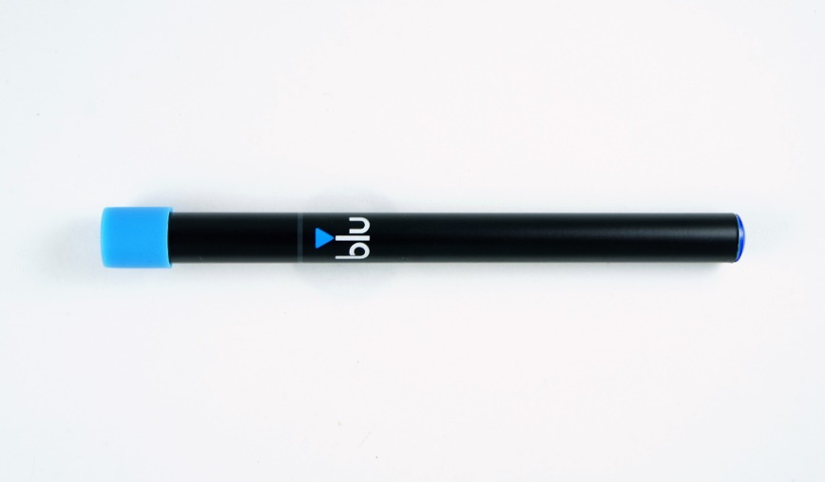

Blu_2
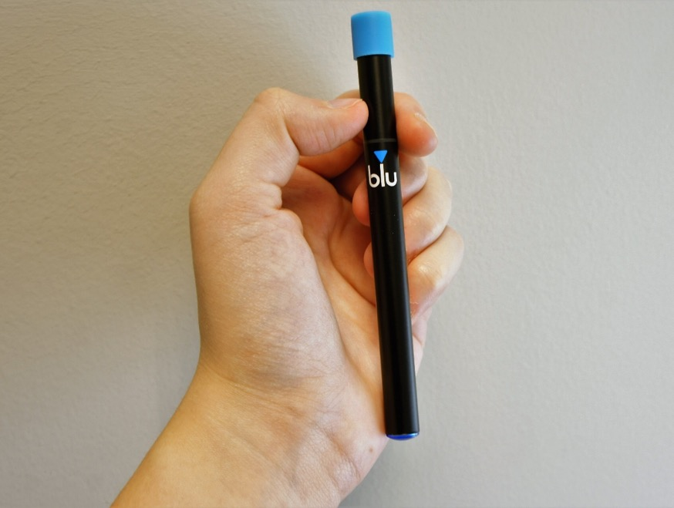

NJOY_1
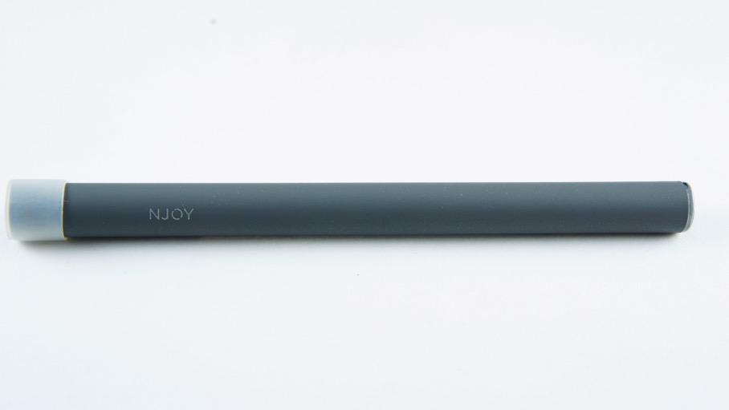

NJOY_2
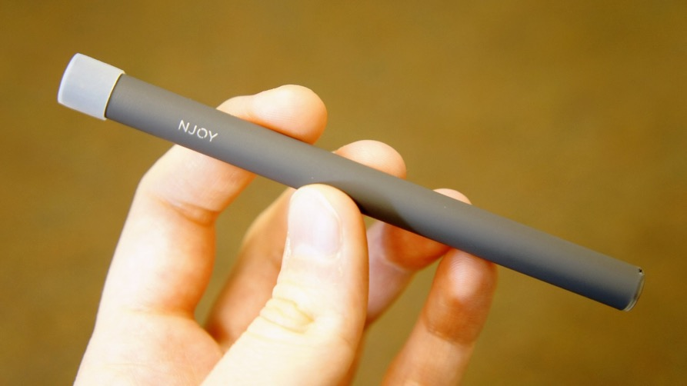

G6_1
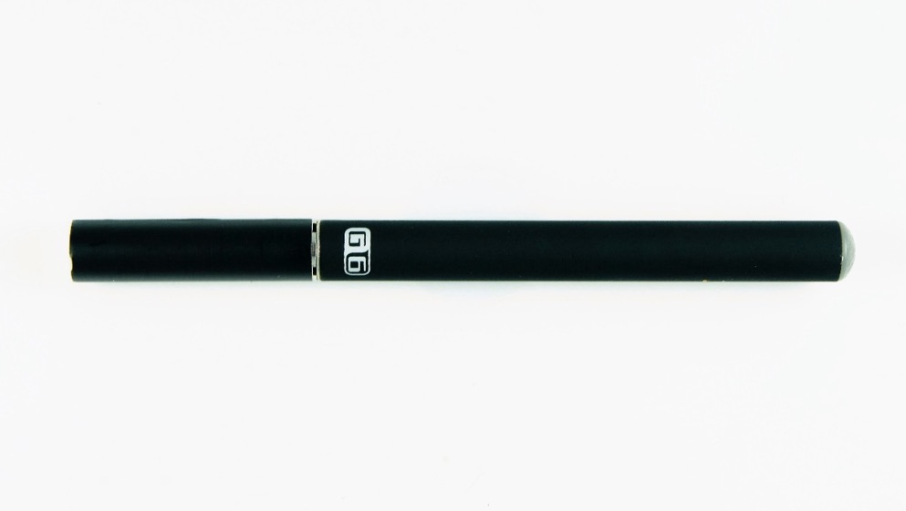

VuseVibe_1
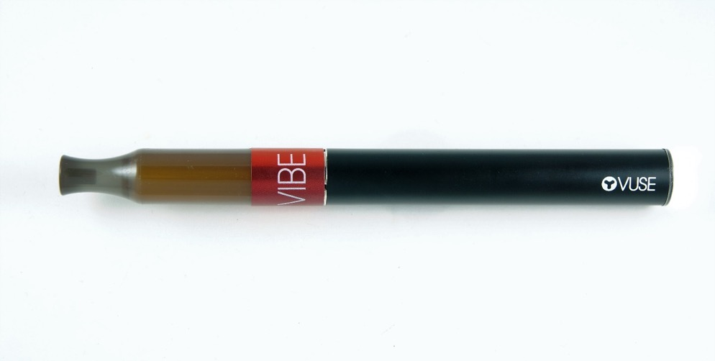

VuseVibe_2
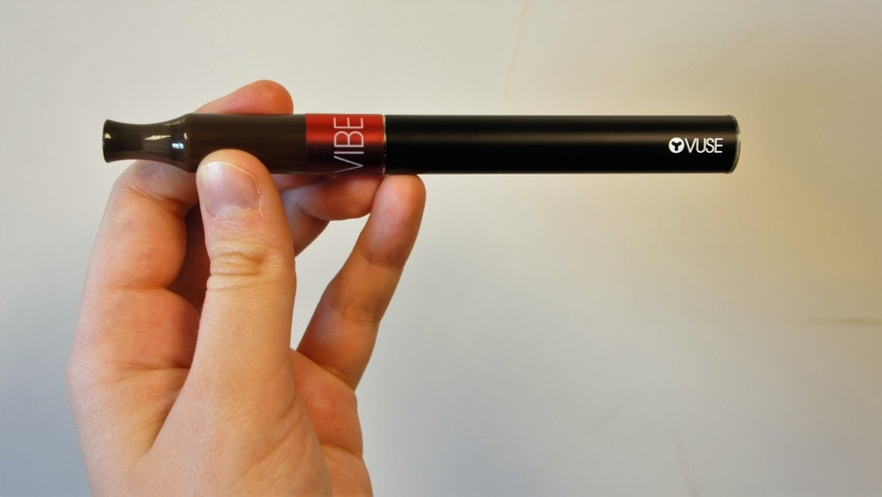

JUUL_1
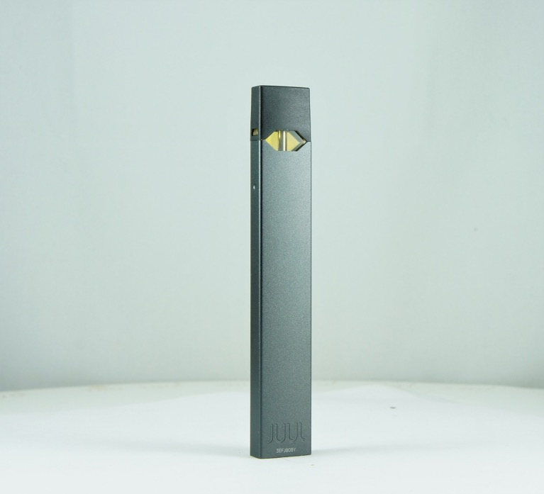

JUUL_2
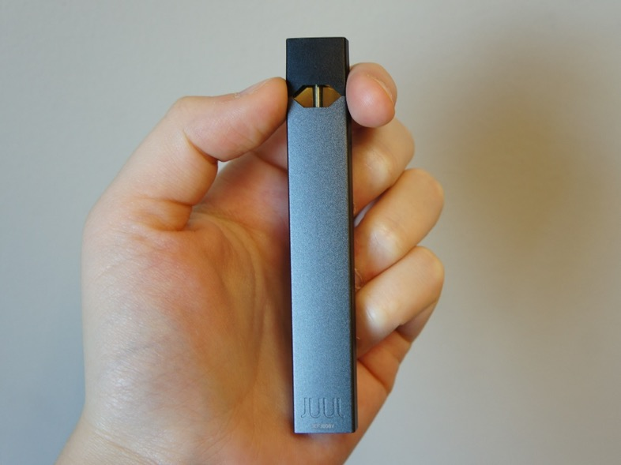

JUUL_Cartridge
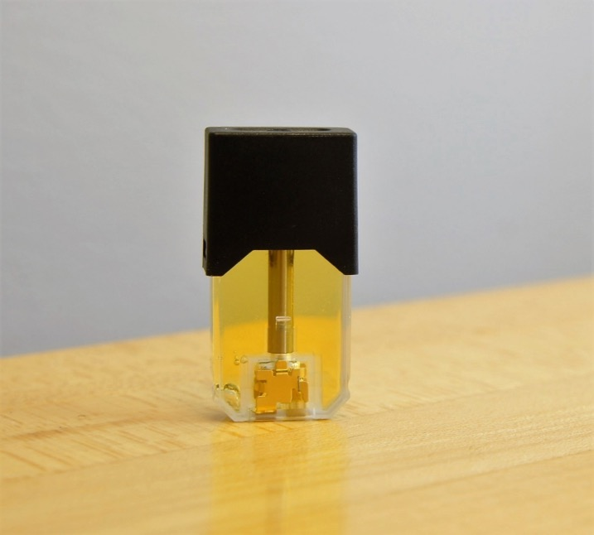

JUUL_Cartridge_2
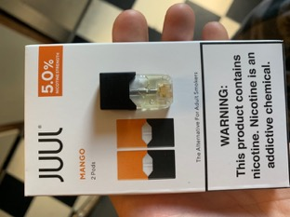

Smok_1
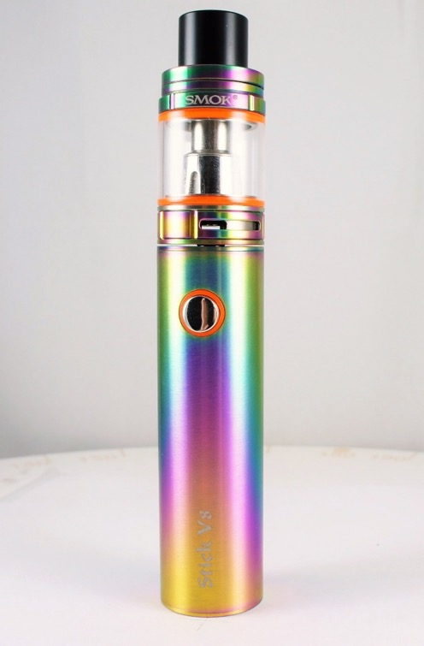

Smok_2
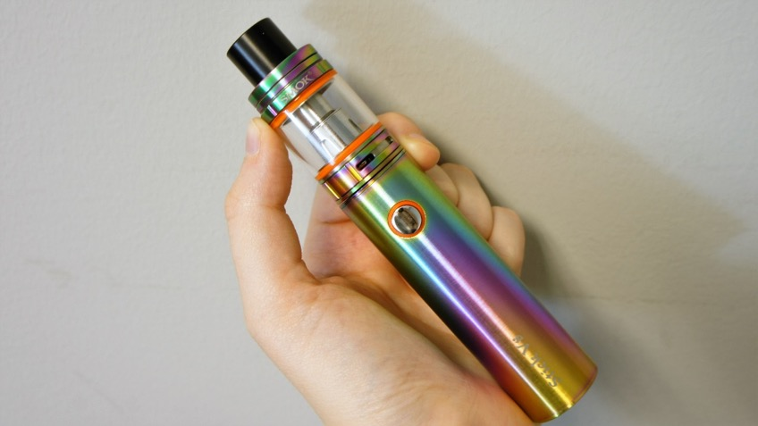

InnokinDV_1
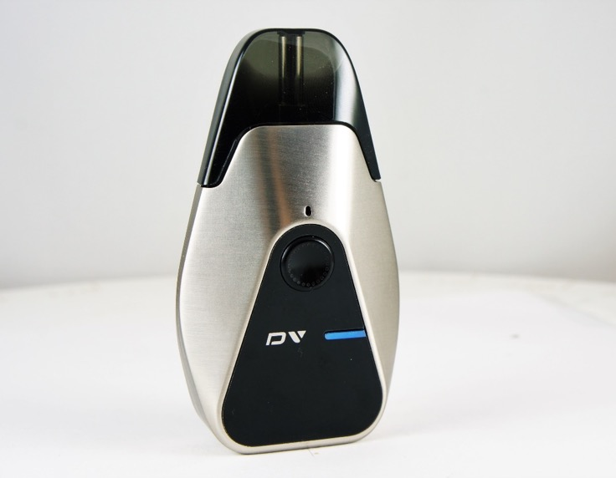

InnokinDV_2
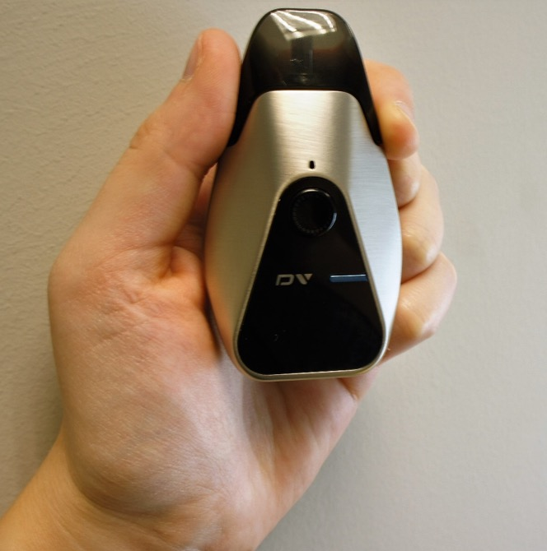

InnokinDV_Display
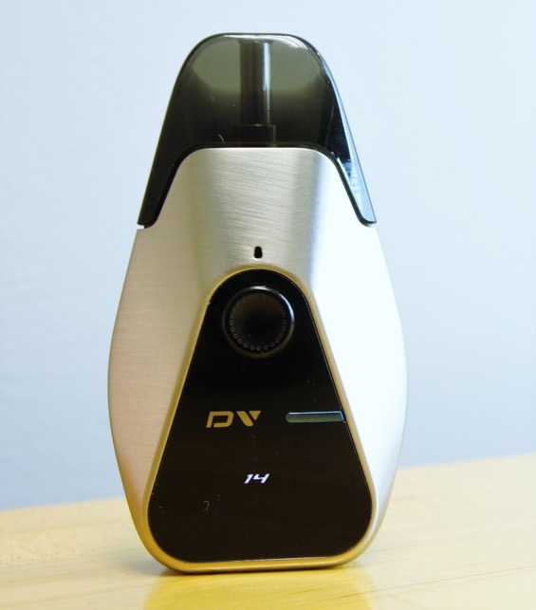

VaporessoLuxeS_1
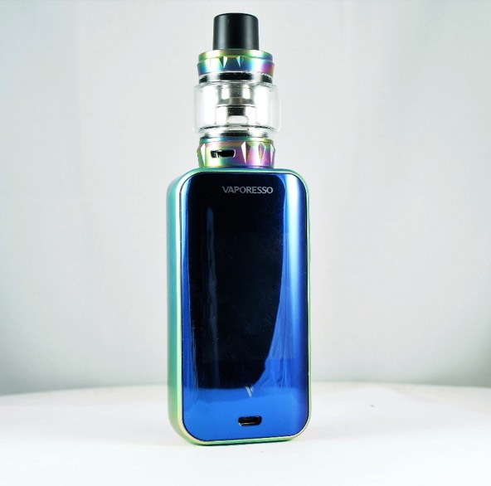

VaporessoLuxeS_2
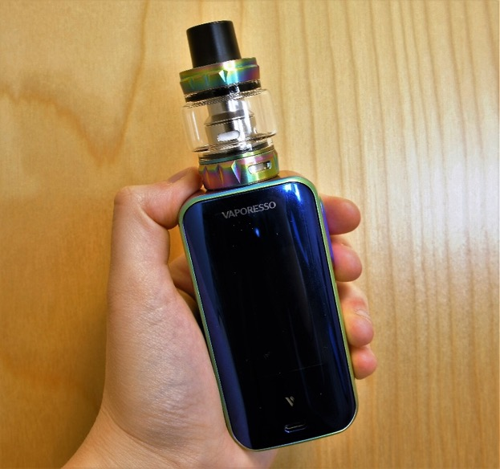

VaporessoLuxeS_Display_1
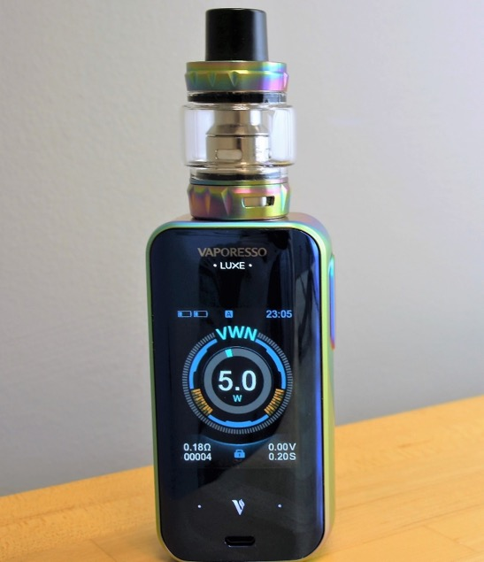

HaloLiquid
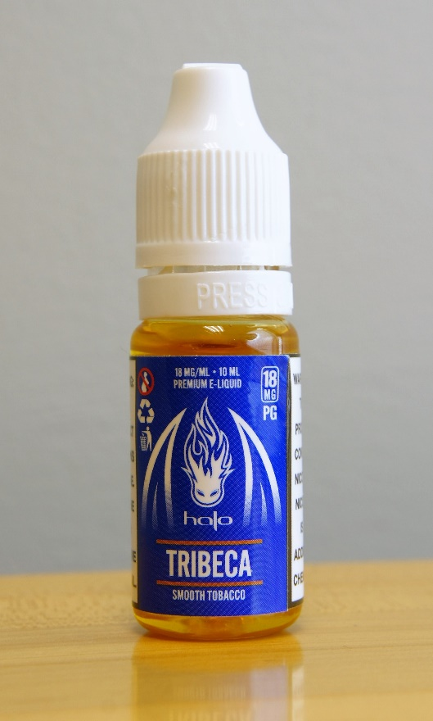

HaloLiquid_LabelOpen_2
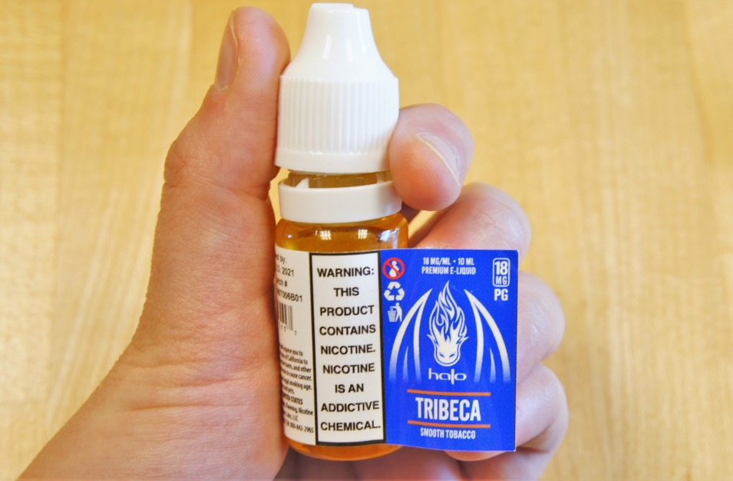

Puffbar_1
Puffbar_2

VaporessoLuxeS_watt
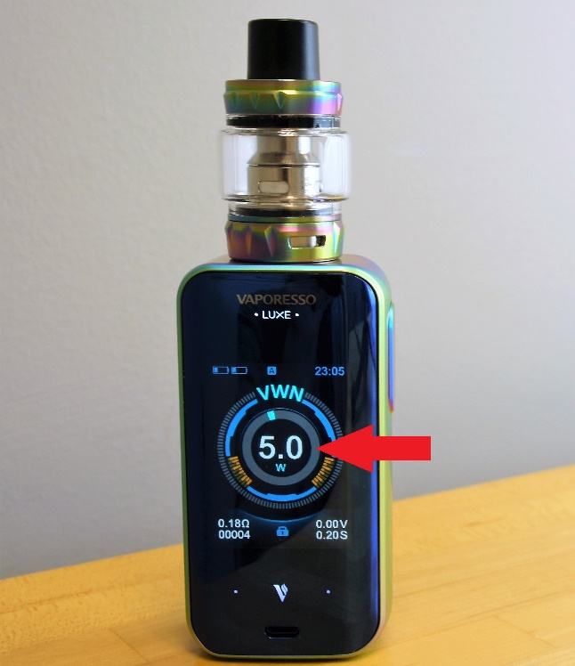

VaporessoLuxeS_watt

VaporessoLuxeS_volt
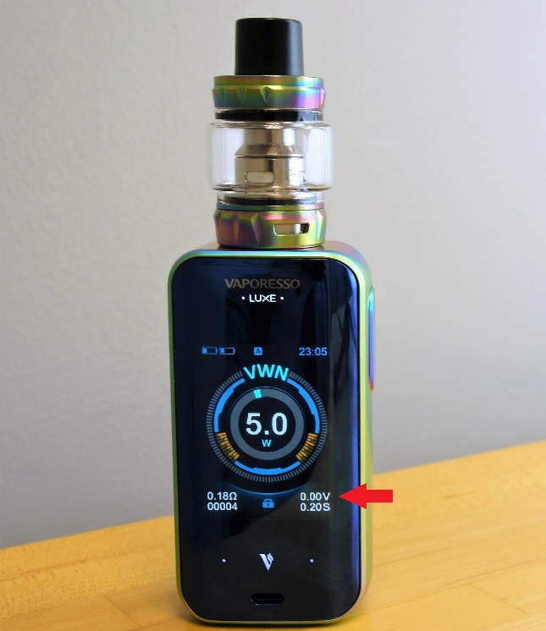

VaporessoLuxeS_ohm
