First page for participants who registered and clicked the personal secure link to the survey:

Thank you for confirming your phone number and welcome to the VAPER Study!

Click [insert appropriate name of button] to determine if you are eligible to participate.

New page:

As a reminder, any perceived attempt to speed through the survey, take the survey more than once, or provide false or misleading information will result in your disqualification from the survey and forfeiture of any promised incentives.

New page:

Screening Questions:

- How old are you? [var: age_b]
  - <18…ineligible
  - 18-20…ineligible
  - 21-24
  - 25-29
  - 30-34
  - 35-39
  - 40-44
  - 45-49
  - 50-54
  - 55-59
  - 60-64
  - 65-69
  - 70+

The next questions are about e-cigarettes or vaping devices.

There are many types of e-cigarettes or vaping devices. All are battery powered and produce vapor instead of smoke. E-cigarettes or vaping devices can be bought as one-time, disposable products, whereas other devices are re-usable.

Some re-usable devices have a tank that can be refilled with e-liquid (also called e-juice, PG juice, and vape juice), THC and CBD concentrates (also called waxes, oils, shatter, and dabs), herbs such as marijuana, and other substances. Other re-usable devices have replaceable cartridges or pods that contain the vaporized substance. Some of these cartridges or pods may be pre-filled and discarded after use, whereas, other cartridges and pods may be refillable.

Disposable e-cigarettes, pre-filled cartridges or pods, and bottles with e-liquids/oils for refillable devices come in many different flavors. Some people customize their own flavor blends by mixing their own flavors or having a vape shop mix their flavors.

Some common brands include JUUL, SMOK, Kandypens, and Grenco Science.

Here are a few examples of e-cigarettes or vaping devices. [DISPLAY ’Blu_1’; ‘NJOY_1’; ‘G6_1’; ‘VuseVibe_1’; ‘JUUL_1’; ‘Smok_1’; ‘InnokinDV_1’; ‘PuffBar_1’; and/or ‘VaporessoLuxeS_1’]
- Have you used an e-cigarette or vaping device to vape THC concentrates, such as waxes, oils, shatter, and/or dabs, in the past 30 days? [var: vape_thc_p30_b]
  - Yes…next Q
  - No…skip to Q4

- [If vape_thc_p30_b is ‘a’]: How many days in a typical week do you use an e-cigarette or vaping device to vape THC concentrates? [var: vape_thc_wk_b]
  - I do not use an e-cigarette or vaping device to vape THC concentrates in a typical week… next Q
  - 1 day…next Q
  - 2 days…next Q
  - 3 days…next Q
  - 4 days…next Q
  - 5 days…next Q
  - 6 days…next Q
  - 7 days…next Q

- Have you used an e-cigarette or vaping device to vape CBD concentrates, such as waxes, oils, shatter, and/or dabs, in the past 30 days? [var: vape_cbd_p30_b]
  - Yes…next Q
  - No…skip to Q6

- [If vape_cbd_p30_b is ‘a’]: How many days in a typical week do you use an e-cigarette or vaping device to vape CBD concentrates? [var: vape_cbd_wk_b]
  - I do not use an e-cigarette or vaping device to vape CBD concentrates in a typical week… next Q
  - 1 day… next Q
  - 2 days… next Q
  - 3 days… next Q
  - 4 days… next Q
  - 5 days…next Q
  - 6 days…next Q
  - 7 days…next Q

- Have you used an e-cigarette or vaping device to vape e-liquids with or without nicotine in the past 30 days? [var: ecig_p30_b]
  - Yes…next Q
  - No…ineligible…skip to ineligible screen

- [If ecig_p30_b is ‘a’]: How many days in a typical week do you use an e-cigarette or vaping device to vape e-liquids with or without nicotine? [var: ecig_wk_b]
  - I do not use an e-cigarette or vaping device to vape e-liquids with or without nicotine in a typical week…ineligible…skip to ineligible screen
  - 1 day…ineligible…skip to ineligible screen
  - 2 days…ineligible…skip to ineligible screen
  - 3 days…ineligible…skip to ineligible screen
  - 4 days…ineligible…skip to ineligible screen
  - 5 days…eligible
  - 6 days…eligible
  - 7 days…eligible

[If age_b is ‘a’ or ‘b’ or ecig_p30_b is ‘b’ or ecig_wk_b is ‘a’, ‘b’, ‘c’, ‘d’ or ‘e’]: Thank you for your time. Unfortunately, you are not currently eligible to participate in this survey.

[If (age_b is 'c', 'd', 'e', 'f', 'g', 'h', 'i', 'j', 'k', 'l' or 'm') and (ecig_p30_b is ‘a’) and (ecig_wk_b is 'f', 'g', or 'h')]: Continue to thc_check_b

Eligible users:

Q1: 21+
Q6: Yes
Q7: 5-7 days

Questionnaire:
Unless otherwise stated, all questions hereafter are in reference to e-cigarettes or vaping devices used to consume e-liquid (also called e-juice, PG juice, and vape juice), which may or may not contain nicotine. They are NOT in reference to use of THC, CBD, marijuana, or other substances.
I acknowledge that I have carefully read and understand the paragraph above. [var: thc_check_b]
  - Yes

- Are you…? [var: gender_b]
  - Male
  - Female
  - I would like to see additional choices
  - Prefer not to answer

- [if gender_b is ‘c’]: Here are some additional choices. Select all that apply. [var: gender_add_b]
  - Transgender man
  - Transgender woman
  - Non-binary
  - Gender non-conforming
  - Gender fluid
  - Genderqueer
  - Agender
  - Two-spirit
  - Another gender not listed here

- [If gender_add_b is ‘i’]: Please specify your gender: [var: gender_other_b; alpha_only]
  - Open ended response

- Approximately how old were you when you first tried an e-cigarette or vaping device? [var: age_firstuse_b; integer; min: 1, max: 125]
  - Open ended response

- Please select the reasons that you tried an e-cigarette or vaping device for the first time. Select all that apply. [var: firstuse_b; checkbox]
  - Curiosity [var: firstuse_b__1]
  - To try the flavor(s) [var: firstuse_b__2]
  - Use by friends [var: firstuse_b__3]
  - Absence of smell [var: firstuse_b__4]
  - For use where smoking is banned [var: firstuse_b__5]
  - To quit or cut down on smoking [var: firstuse_b__6]
  - Some other reason [var: firstuse_b__7]

- [If firstuse_b is ‘g’]: Please specify: [var: firstuse_sp_b]
  - Open ended response

- What is your PRIMARY reason for CONTINUING to use an e-cigarette or vaping device? [var: continue_b]
  - To quit smoking
  - To cut down smoking
  - To use when I am not allowed to smoke
  - Absence of smell
  - To socialize
  - To have a longer break at work
  - Because I enjoy the flavor
  - Because I enjoy the boost
  - Because I am addicted
  - Curiosity/just want to try them
  - Some other reason

- [If continue_b is ‘k’]: Please specify: [var: continue_sp_b]
  - Open ended response

- How many different e-cigarette or vaping devices did you use in the past week? [var: num_devices_b; integer; min: 0]
  - Open ended response

Thinking about your most used device during the past week, please answer the following questions.

- [If num_devices_b > 0]: What is the brand AND model of the device (e.g., JUUL, Vaporesso Luxe, Voopoo Drag 2, etc.)? [var: ecig_brandmodel_b]
  - Open ended response

- [If num_devices_b > 0]: How did you buy the device? [var: how_device_b]
  - In person
  - From the internet
  - Some other means
  - I did not buy the e-cig or vaping device

- [If how_device_b is ‘c’]: Please specify: [var: how_device_sp_b]
  - Open ended response

- [If how_device_b is ‘a’]: Where did you buy the device? [var: where_device_b]
  - A mall kiosk
  - A convenience store or gas station
  - A supermarket or grocery store
  - A drug store
  - A warehouse club, such as Sam’s or Costco
  - A vape shop
  - A marijuana dispensary or retailer
  - A smoke shop, tobacco specialty store, or tobacco outlet store
  - A duty-free shop or military commissary
  - A bar, pub, restaurant, or casino
  - A friend or relative
  - A swap meet or flea market
  - A liquor store
  - Somewhere else

- [If where_device_b is ‘n’]: Please specify: [var: where_device_sp_b]
  - Open ended response

- [If how_device_b is ‘b’]: Was the device… [var: device_delivery_b]
  - Shipped to you by a postal service like USPS, UPS, or FedEx
  - Delivered to you by an on-demand delivery service like Postmates or goPuff
  - Picked up in-store

- [If (num_devices_b > 0) and (how_device_b is ‘a’ or how_device_b is ‘b’ or how_device_b is ‘c’)]: About how much did you pay for your device or pack of disposable devices? Do not include the cost of additional pods/cartridges or accessories unless they were included in a starter kit. [var: device_price_b]
  - Less than $10
  - $10-20
  - $21-$100
  - More than $100

- [If num_devices_b > 0]: Is the device… [var: device_type_b]
  - Re-usable (i.e., you recharge the device when the battery life is low or at 0%)
  - Disposable (i.e., you discard entire device when the battery life is low or at 0%)

- [If device_type_b is ‘a’]: Does the device have SETTINGS that allow you to modify power or vapor volume? [var: device_mod_set_b]
  - Yes
  - No

- [If device_type_b is ‘a’]: Does the device have a VISUAL DISPLAY that allows you to see the wattage or other vape settings?

Battery life indicators do NOT count as visual displays. [var: device_display_b]
  - Yes
  - No

- [If num_devices_b > 0]: Do you know the device’s current wattage (watts, W)?

The wattage of a device is not always available but may be found on the device itself or on the packaging for the device. [var: watts_b]
  - Yes, I know the wattage
  - No, I don’t know the wattage

[If device_mod_set_b is ‘a’]: Below is an example of where you might find the wattage on your device. [DISPLAY ’VaporessoLuxeS_watt’]

- [If watts_b is ‘a’]: Please specify the wattage in watts (W):

Record your answer with 1 decimal point. For example, if the packaging or device shows 20 watts, you will record 20.0. [var: watts_sp_b; number_1dp; min: 0, max: 525]
  - Open ended response

- [If num_devices_b > 0]: Do you know the device’s current voltage (volts, V)?

The voltage of a device is not always available but may be found on the device itself or on the packaging for the device. [var: volts_b]
  - Yes, I know the voltage
  - No, I don’t know the voltage

[If device_mod_set_b is ‘a’]: Below is an example of where you might find the voltage on your device. [DISPLAY ’VaporessoLuxeS_volt’]

- [If volts_b is ‘a’]: Please specify the voltage in volts (V):

Record your answer with 1 decimal point. For example, if the packaging or device shows 5 volts, you will record 5.0. [var: volts_sp_b; number_1dp; min: 0, max: 18.0]
  - Open ended response

- [If num_devices_b > 0]: Do you know the device’s current coil resistance (ohms, Ω)?

The resistance of a device is not always available but may be found on the device or coil itself or on the packaging for the device. [var: coil_ohm_b]
  - Yes, I know the coil resistance
  - No, I don’t know the coil resistance

[If num_devices_b > 0]: Below is an example of where you might find the resistance on your device. [DISPLAY ’VaporessoLuxeS_ohm’]

- [If coil_ohm_b is ‘a’]: Please specify the resistance in ohms (Ω):

Record your answer with 2 decimal points. For example, if the packaging, device, or coil shows 3 ohms, you will record 3.00. [var: coil_ohm_sp_b; number_2dp; min: 0, max: 9.00]
  - Open ended response

- [If device_type_b is ‘a’ and coil_ohm_b is ‘b’]: Which of the following best describes the coil? [var: coil_type_b]
  - The coil is permanently attached to the tank/cartridge/pod
  - The coil can be separated or unscrewed from the tank/cartridge/pod
  - Don’t know

- [If coil_type_b is ‘b’]: Do you know the brand AND model of the device’s current coil?

For example, it might be called something like “QF Strip Coil 0.15Ω”. [var: coil_brand_b]
  - Yes
  - No
  - Not applicable because I wrap my own coils

- [If coil_brand_b is ‘a’]: Please specify the brand and model: [var: coil_brand_sp_b]
  - Open ended response

- [If coil_type_b is ‘a’]: Do you know the brand AND model of the device’s current tank/cartridge/pod?

For example, it might be called something like “1.8 ohm POD-S1 Cartridge”. [var: pod_brand_b]
  - Yes
  - No

- [If pod_brand_b is ‘a’]: Please specify the brand and model: [var: pod_brand_sp_b]
  - Open ended response

- [If device_type_b is ‘a’]: When the device runs out of e-liquid, do you TYPICALLY… [var: pod_type_b]
  - Discard the empty cartridge or pod and replace with a new and unused cartridge or pod prefilled with e-liquid
  - Refill the empty tank/cartridge/pod with e-liquid from a larger container(s) of e-liquid

- [If pod_type_b is ‘b’]: Which of the following best describes your device? [var: tankvspod_b]
  - My device has a refillable tank
  - My device has a refillable pod or cartridge
  - Don’t know

- Please select the answer that is NOT a fruit: [var: qc_1_b]
  - Apple
  - Banana
  - Pineapple
  - Chair
  - Mango

[If pod_type_b is ‘a’…Continue to prompt before rd_liq_flavor_b]
[If pod_type_b is ‘b’…Skip to prompt before rr_liquid_type_b]
[If device_type_b is ‘b’…Skip to prompt before d_liq_flavor_b]

[If pod_type_b is ‘a’]: Thinking about your most used e-liquid in a cartridge or pod for your most used device FROM THE PAST WEEK, please answer the following questions.

- [If pod_type_b is ‘a’]: What is the flavor of the e-liquid? [var: rd_liq_flavor_b]
  - Tobacco
  - Tobacco menthol
  - Menthol
  - Mint
  - A flavor like fruit, candy, alcohol, coffee, vanilla, or other food/drink
  - No flavor

- [If rd_liq_flavor_b is ‘e’]: Please specify the flavor: [var: rd_flavor_sp_b]
  - Open ended response

- [If pod_type_b is ‘a’]: Do you know how much nicotine is in the e-liquid? [var: rd_liq_nic_b]
  - Yes, I know the mg of nicotine
  - Yes, I know the % of nicotine
  - No

- [If rd_liq_nic_b is ‘a’]: Please specify:

Record your answer with 1 decimal point. For example, if the packaging shows 3 mg of nicotine, you will record 3.0. [var: rd_liq_nic_mg_b; number_1dp; min: 0, max: 90]
  - Open ended response

- [If rd_liq_nic_b is ‘b’]: Please specify:

Record your answer with 1 decimal point. For example, if the packaging shows 3% nicotine, you will record 3.0. [var: rd_liq_nic_pct_b; number_1dp; min: 0, max: 9]
  - Open ended response

- [If pod_type_b is ‘a’]: Does the e-liquid contain nicotine salts? [var: rd_liq_salts_b]
  - Yes
  - No
  - Don’t know

- [If pod_type_b is ‘a’]: How did you last buy the cartridge or pod? [var: rd_how_pod_b]
  - In person
  - From the internet
  - Some other means
  - I did not buy the e-liquid

- [If rd_how_pod_b is ‘c’]: Please specify: [var: rd_how_pod_sp_b]
  - Open ended response

- [If rd_how_pod_b is ‘a’]: Where did you last buy the cartridge or pod? [var: rd_where_pod_b]
  - A mall kiosk
  - A convenience store or gas station
  - A supermarket or grocery store
  - A drug store
  - A warehouse club, such as Sam’s or Costco
  - A vape shop
  - A marijuana dispensary or retailer
  - A smoke shop, tobacco specialty store, or tobacco outlet store
  - A duty-free shop or military commissary
  - A bar, pub, restaurant, or casino
  - A friend or relative
  - A swap meet or flea market
  - A liquor store
  - Somewhere else

- [If rd_where_pod_b is ‘n’]: Please specify: [var: rd_where_pod_sp_b]
  - Open ended response

- [If rd_how_pod_b is ‘b’]: Was the cartridge or pod… [var: rd_pod_delivery_b]
  - Shipped to you by a postal service like USPS, UPS, or FedEx
  - Delivered to you by an on-demand delivery service like Postmates or goPuff
  - Picked up in-store

- [If pod_type_b is ‘a’]: Approximately how many days does it take for you to finish the cartridge or pod? [var: rd_pod_days_b]
  - Less than one day
  - One day
  - More than one day
  - Don’t know

- [If rd_pod_days_b is ‘c’]: Please specify the number of days: [var: rd_pod_days_sp_b; integer; min: 2]
  - Open ended response

- [If pod_type_b is ‘a’]: Approximately how many different flavors did you vape in the past week with your most used device? [var: rd_num_flavors_b; integer; min: 0]
  - Open ended response

- [If pod_type_b is ‘a’]: What flavor did you use SECOND MOST OFTEN in the past week with your most used device? [var: rd_flav2_b]
  - Tobacco
  - Tobacco menthol
  - Menthol
  - Mint
  - A flavor like fruit, candy, alcohol, coffee, vanilla, or other food/drink
  - No flavor
  - None of the above because I use only one flavor

- [If rd_flav2_b is ‘e’]: Please specify the flavor: [var: rd_flav2_sp_b]
  - Open ended response

[If pod_type_b is ‘a’]: Please take a moment to get your most used device and your most used cartridge/pod for the device FROM THE PAST WEEK. The next 2-3 prompts will ask you to upload PHOTOS of each.

DO NOT UPLOAD PHOTOS YOU FOUND ON THE INTERNET OR PHOTOS THAT CAN BE USED TO IDENTIFY YOU OR ANOTHER PERSON.

[If pod_type_b is ‘a’]: Please take a picture of your most used device with the brand information clearly visible.

You may upload two pictures OF THE SAME DEVICE if this will make the brand information more visible.

Below are examples of the photo you should take. [DISPLAY ‘VuseVibe_2’ and/or ‘JUUL_2’]

[If pod_type_b is ‘a’]: Photo 1 (REQUIRED): [var: rd_device_pic_b]

[If pod_type_b is ‘a’]: Photo 2 (OPTIONAL): [var: rd_device_pic2_b]

[If device_display_b is ‘a’ AND pod_type_b is ‘a’]: Please take a picture of your most used device's visual display when it shows information about your current vape settings.

Below are example photos. [DISPLAY ‘InnokinDV_Display’ and/or ‘VaporessoLuxeS_Display_1’]

[If device_display_b is ‘a’ AND pod_type_b is ‘a’]: Photo 1 (REQUIRED): [var: rd_display_pic_b]

- [If pod_type_b is ‘a’]: Do you have your most used cartridge or pod for your most used device available for a photo? [var: pod_avail_b]
  - Yes
  - No

- [If pod_avail_b is ‘b’]: Please explain why you are not able to submit a photo of the cartridge or pod: [var: pod_avail_sp_b]
  - Open ended response

[If pod_avail_b is ‘a’]: Please take a PHOTO of your most used cartridge or pod for your most used device. If on the cartridge or pod, the photo should clearly show the brand, flavor, and mg or percent of nicotine.

You may upload two pictures OF THE SAME CARTRIDGE OR POD if this will make the information more visible.

Below are examples of the photo you should take. [DISPLAY ‘JUUL_Cartridge’ and/or ‘JUUL_Cartridge_2’]

[If pod_avail_b is ‘a’]: Photo 1 (REQUIRED): [var: rd_podcart_pic_b]

[If pod_avail_b is ‘a’]: Photo 2 (OPTIONAL): [var: rd_podcart_pic2_b]

[skip to ecig_addictive_b]

[If pod_type_b is ‘b’]: Thinking about your most used e-liquid for your most used device FROM THE PAST WEEK, please answer the following questions.

- [If pod_type_b is ‘b’]: Is your most used e-liquid a… [var: rr_liquid_type_b]
  - Customized flavor blend – mixed yourself
  - Customized flavor blend – mixed by someone else for only you
  - Pre-mixed flavor blend – mixed for sale to many customers

- [If rr_liquid_type_b is ‘c’]: Do you know the brand on the e-liquid bottle (e.g., Naked 100, Beard Vape, Milkman, etc.)? [var: rr_nc_liq_brand_b]
  - Yes
  - No

- [If rr_nc_liq_brand_b is ‘a’]: Please specify the brand: [var: rr_nc_liq_brand_sp_b]
  - Open ended response

- [If rr_liquid_type_b is ‘c’]: What is the flavor of the e-liquid? [var: rr_nc_liq_flavor_b]
  - Tobacco
  - Tobacco menthol
  - Menthol
  - Mint
  - A flavor like fruit, candy, alcohol, coffee, vanilla, or other food/drink
  - No flavor

- [If rr_nc_liq_flavor_b is ‘e’]: Please specify the flavor: [var: rr_nc_liq_flavor_sp_b]
  - Open ended response

- [If rr_liquid_type_b is ‘c’]: Do you know how much nicotine is in the e-liquid? [var: rr_nc_liq_nic_b]
  - Yes, I know the mg of nicotine
  - Yes, I know the % of nicotine
  - No

- [If rr_nc_liq_nic_b is ‘a’]: Please specify:

Record your answer with 1 decimal point. For example, if the packaging shows 3 mg of nicotine, you will record 3.0. [var: rr_nc_liq_nic_mg_b; number1_dp; min: 0, max 90]
  - Open ended response

- [If rr_nc_liq_nic_b is ‘b’]: Please specify:

Record your answer with 1 decimal point. For example, if the packaging shows 3% nicotine, you will record 3.0. [var: rr_nc_liq_nic_pct_b; number_1dp; min: 0, max: 9]
  - Open ended response

- [If rr_liquid_type_b is ‘c’]: How often do you add extra nicotine to the e-liquid? These are sometimes called “nicotine shots” or “nicotine boosters”. [var: extra_nic_b]
  - Every time
  - Very often
  - Sometimes
  - Rarely
  - I have never added extra nicotine to my e-liquid

- [If rr_liquid_type_b is ‘c’]: Does the e-liquid contain nicotine salts? [var: rr_nc_liq_salts_b]
  - Yes
  - No
  - Don’t know

- [If rr_liquid_type_b is ‘c’]: How did you last buy the e-liquid? [var: rr_nc_how_liq_b]
  - In person
  - From the internet
  - Some other means
  - I did not buy the e-liquid

- [If rr_nc_how_liq_b is ‘c’]: Please specify: [var: rr_nc_how_liq_sp_b]
  - Open ended response

- [If rr_nc_how_liq_b is ‘a’]: Where did you last buy the e-liquid? [var: rr_nc_where_liq_b]
  - A mall kiosk
  - A convenience store or gas station
  - A supermarket or grocery store
  - A drug store
  - A warehouse club, such as Sam’s or Costco
  - A vape shop
  - A marijuana dispensary or retailer
  - A smoke shop, tobacco specialty store, or tobacco outlet store
  - A duty-free shop or military commissary
  - A bar, pub, restaurant, or casino
  - A friend or relative
  - A swap meet or flea market
  - A liquor store
  - Somewhere else

- [If rr_nc_where_liq_b is ‘n’]: Please specify: [var: rr_nc_where_liq_sp_b]
  - Open ended response

- [If rr_nc_how_liq_b is ‘b’]: Was the e-liquid… [var: rr_nc_liq_delivery_b]
  - Shipped to you by a postal service like USPS, UPS, or FedEx
  - Delivered to you by an on-demand delivery service like Postmates or goPuff
  - Picked up in-store

- [If rr_liquid_type_b is ‘c’]: Do you know the bottle size (in milliliters) of your most used e-liquid that you last purchased? [var: rr_nc_liq_size_b]
  - Yes
  - No

- [If rr_nc_liq_size_b is ‘a’]: Please specify the bottle size (in mL): [var: rr_nc_liq_size_sp_b; integer; min: 1]
  - Open ended response

- [If rr_liquid_type_b is ‘c’]: Approximately how many days does it take for you to finish your most used e-liquid bottle? [var: rr_nc_liq_days_b]
  - Less than one day
  - One day
  - More than one day
  - Don’t know

- [If rr_nc_liq_days_b is ‘c’]: Please specify the number of days: [var: rr_nc_liq_days_sp_b; integer; min: 2]
  - Open ended response

- [If rr_liquid_type_b is ‘c’]: Approximately how many different customized flavor blends – flavors you mixed yourself or mixed for you by someone else – did you vape in the past week with your most used device? [var: rr_nc_num_custflav_b; integer; min: 0]
  - Open ended response

- [If rr_nc_num_custflav_b is greater than ‘0’]: Did you mix any of the customized flavor blends yourself in the past week? [var: rr_nc_selfmix_b]
  - Yes
  - No

- [If rr_liquid_type_b is ‘c’]: Approximately how many different pre-mixed flavor blends – flavors mixed for sale to many customers -- did you vape in the past week with your most used device? [var: rr_nc_num_ncflav_b; integer; min: 0]
  - Open ended response

- [If rr_liquid_type_b is ‘c’]: What flavor did you use SECOND MOST OFTEN in the past week with your most used device? [var: rr_nc_flav2_b]
  - Tobacco (pre-mixed flavor)
  - Tobacco menthol (pre-mixed flavor)
  - Menthol (pre-mixed flavor)
  - Mint (pre-mixed flavor)
  - A pre-mixed flavor blend like fruit, candy, alcohol, coffee, vanilla, or other food/drink
  - A customized flavor blend
  - No flavor
  - None of the above because I use only one flavor

- [If rr_nc_flav2_b is ‘e’]: Please specify the flavor: [var: rr_nc_flav2_nc_sp_b]
  - Open ended response

- [If rr_nc_flav2_b is ‘f’]: Please specify the flavor: [var: rr_nc_flav2_c_sp_b]
  - Open ended response

[skip to prompt before rr_device_pic_b]

- [If rr_liquid_type_b is ‘a’ OR rr_liquid_type_b is ‘b’]: What is the flavor of the blend? [var: rr_csm_flavor_b]
  - Tobacco
  - Tobacco menthol
  - Menthol
  - Mint
  - A flavor like fruit, candy, alcohol, coffee, vanilla, or other food/drink
  - No flavor

- [If rr_csm_flavor_b is ‘e’]: Please specify the flavor: [var: rr_csm_flavor_sp_b]
  - Open ended response

- [If rr_liquid_type_b is ‘a’ OR rr_liquid_type_b is ‘b’]: Do you know how much nicotine is in the flavor blend? [var: rr_csm_liq_nic_b]
  - Yes, I know the mg of nicotine
  - Yes, I know the % of nicotine
  - No

- [If rr_csm_liq_nic_b is ‘a’]: Please specify:

Record your answer with 1 decimal point. For example, if the packaging shows 3 mg of nicotine, you will record 3.0. [var: rr_c_liq_nic_mg_b; number_1dp; min: 0, max: 90]
  - Open ended response

- [If rr_csm_liq_nic_b is ‘b’]: Please specify:

Record your answer with 1 decimal point. For example, if the packaging shows 3% nicotine, you will record 3.0. [var: rr_c_liq_nic_pct_b; number_1dp; min: 0, max: 9]
  - Open ended response

- [If rr_liquid_type_b is ‘a’ OR rr_liquid_type_b is ‘b’]: Does the flavor blend contain nicotine salts? [var: rr_csm_liq_salts_b]
  - Yes
  - No
  - Don’t know

- [If rr_liquid_type_b is ‘a’]: How did you last buy the e-liquids needed to make the flavor blend? Select all that apply. [var: rr_sm_how_liq_b; checkbox]
  - In person [var: rr_sm_how_liq_b___1]
  - From the internet [var: rr_sm_how_liq_b___2]
  - Some other means [var: rr_sm_how_liq_b___3]
  - I did not buy all of e-liquids [var: rr_sm_how_liq_b___4]

- [If rr_sm_how_liq_b is ‘c’]: Please specify: [var: rr_sm_how_liq_sp_b]
  - Open ended response

- [If rr_sm_how_liq_b is ‘a’]: Where did you last buy the e-liquids to make the flavor blend? Select all that apply. [var: rr_sm_where_liq_b; checkbox]
  - A mall kiosk [var: rr_sm_where_liq_b___1]
  - A convenience store or gas station [var: rr_sm_where_liq_b___2]
  - A supermarket or grocery store [var: rr_sm_where_liq_b___3]
  - A drug store [var: rr_sm_where_liq_b___4]
  - A warehouse club, such as Sam’s or Costco [var: rr_sm_where_liq_b___5]
  - A vape shop [var: rr_sm_where_liq_b___6]
  - A marijuana dispensary or retailer [var: rr_sm_where_liq_b___7]
  - A smoke shop, tobacco specialty store, or tobacco outlet store [var: rr_sm_where_liq_b___8]
  - A duty-free shop or military commissary [var: rr_sm_where_liq_b___9]
  - A bar, pub, restaurant, or casino [var: rr_sm_where_liq_b___10]
  - A friend or relative [var: rr_sm_where_liq_b___11]
  - A swap meet or flea market [var: rr_sm_where_liq_b___12]
  - A liquor store [var: rr_sm_where_liq_b___13]
  - Somewhere else [var: rr_sm_where_liq_b___14]

- [If rr_sm_where_liq_b is ‘n’]: Please specify: [var: rr_sm_where_liq_sp_b]
  - Open ended response

- [If rr_sm_how_liq_b is ‘b’]: Were the e-liquids for the flavor blend… (select all that apply) [var: rr_sm_liq_delivery_b; checkbox]
  - Shipped to you by a postal service like USPS, UPS, or FedEx [var: rr_sm_liq_delivery_b___1]
  - Delivered to you by an on-demand delivery service like Postmates or goPuff [var: rr_sm_liq_delivery_b___2]
  - Picked up in-store [var: rr_sm_liq_delivery_b___3]

- [If rr_liquid_type_b is ‘b’]: How did you last buy the flavor blend? [var: rr_c_how_liq_b]
  - In person
  - From the internet
  - Some other means
  - I did not buy the flavor blend

- [If rr_c_how_liq_b is ‘c’]: Please specify: [var: rr_c_how_liq_sp_b]
  - Open ended response

- [If rr_c_how_liq_b is ‘a’]: Where did you last buy the flavor blend? [var: rr_c_where_liq_b]
  - A mall kiosk
  - A convenience store or gas station
  - A supermarket or grocery store
  - A drug store
  - A warehouse club, such as Sam’s or Costco
  - A vape shop
  - A marijuana dispensary or retailer
  - A smoke shop, tobacco specialty store, or tobacco outlet store
  - A duty-free shop or military commissary
  - A bar, pub, restaurant, or casino
  - A friend or relative
  - A swap meet or flea market
  - A liquor store
  - Somewhere else

- [If rr_c_where_liq_b is ‘n’]: Please specify: [var: rr_c_where_liq_sq_b]
  - Open ended response

- [If rr_c_how_liq_b is ‘b’]: Was the flavor blend… [var: rr_c_liq_delivery_b]
  - Shipped to you by a postal service like USPS, UPS, or FedEx
  - Delivered to you by an on-demand delivery service like Postmates or goPuff
  - Picked up in-store

- [If rr_liquid_type_b is ‘a’ OR rr_liquid_type_b is ‘b’]: Do you know the bottle size (in milliliters) of your most used flavor blend? [var: rr_csm_liq_size_b]
  - Yes
  - No

- [If rr_csm_liq_size_b is ‘a’]: Please specify the bottle size (in mL): [var: rr_csm_liq_size_sp_b; integer; min: 1]
  - Open ended response

- [If rr_liquid_type_b is ‘a’ OR rr_liquid_type_b is ‘b’]: Approximately how many days does it take for you to finish the e-liquid bottle with your most used flavor blend? [var: rr_csm_liq_days_b]
  - Less than one day
  - One day
  - More than one day
  - Don’t know

- [If rr_csm_liq_days_b is ‘c’]: Please specify the number of days: [var: rr_csm_liq_days_sp_b; integer; min: 2]
  - Open ended response

- [If rr_liquid_type_b is ‘a’ OR rr_liquid_type_b is ‘b’]: Approximately how many different customized flavor blends – flavors you mixed yourself or mixed for you by someone else – did you vape in the past week with your most used device? [var: rr_csm_num_cflav_b; integer; min: 0]
  - Open ended response

- [If rr_liquid_type_b is ‘b’ AND rr_csm_num_cflav_b is greater than ‘0’]: Did you mix any of the customized flavor blends yourself in the past week? [var: rr_c_selfmix_b]
  - Yes
  - No

- [If rr_liquid_type_b is ‘a’ OR rr_liquid_type_b is ‘b’]: Approximately how many different pre-mixed flavor blends – flavors mixed for sale to many customers -- did you vape in the past week with your most used device? [var: rr_csm_num_ncflav_b; integer; min: 0]
  - Open ended response

- [If rr_liquid_type_b is ‘a’ OR rr_liquid_type_b is ‘b’]: What flavor did you use SECOND MOST OFTEN in the past week with your most used device? [var: rr_csm_liq_flav2_b]
  - Tobacco (pre-mixed flavor)
  - Tobacco menthol (pre-mixed flavor)
  - Menthol (pre-mixed flavor)
  - Mint (pre-mixed flavor)
  - A pre-mixed flavor blend like fruit, candy, alcohol, coffee, vanilla, or other food/drink
  - A customized flavor blend
  - No flavor
  - None of the above because I use only one flavor

- [If rr_csm_liq_flav2_b is ‘e’]: Please specify the flavor: [var: rr_csm_flav2_nc_sp_b]
  - Open ended response

- [If rr_csm_liq_flav2_b is ‘f’]: Please specify the flavor: [var: rr_csm_flav2_c_sp_b]
  - Open ended response

[If pod_type_b is ‘b’]: Please take a moment to get your most used device and your most used e-liquid bottle for the device FROM THE PAST WEEK. The next 2-3 prompts will ask you to upload PHOTOS of each.

DO NOT UPLOAD PHOTOS YOU FOUND ON THE INTERNET OR PHOTOS THAT CAN BE USED TO IDENTIFY YOU OR ANOTHER PERSON.

[If pod_type_b is ‘b’]: Please take a picture of your most used device with the brand information clearly visible.

You may upload two pictures OF THE SAME DEVICE if this will make the brand information more visible.

Below are examples of the photo you should take. [DISPLAY ‘SMOK_2’, ‘InnokinDV_2’, and/or ‘VaporessoLuxeS_2’]

[If pod_type_b is ‘b’]: Photo 1 (REQUIRED): [var: rr_device_pic_b]

[If pod_type_b is ‘b’]: Photo 2 (OPTIONAL): [var: rr_device_pic2_b]

[If pod_type_b is ‘b’ AND device_display_b is ‘a’]: Please take a picture of your most used device's visual display when it shows information about your current vape settings.

Below are example photos. [DISPLAY ‘InnokinDV_Display’ and/or ‘VaporessoLuxeS_Display_1’]

[If pod_type_b is ‘b’ AND device_display_b is ‘a’]: Photo 1 (REQUIRED): [var: rr_display_pic_b]

- [If pod_type_b is ‘b’]: Do you have your most used e-liquid bottle for your most used device available for a photo? [var: rr_liq_avail_b]
  - Yes
  - No

- [If rr_liq_avail_b is ‘b’]: Please explain why you are not able to submit a photo of the e-liquid bottle [var: rr_liq_avail_sp_b]
  - Open ended response

- [If rr_liq_avail_b is ‘a’]: Please take a PHOTO of your most used e-liquid bottle for your most used device. If on the e-liquid bottle, the photo should clearly show the brand, flavor, and mg or percent of nicotine.

You may upload two pictures OF THE SAME E-LIQUID BOTTLE if this will make the information more visible.

Below are examples of the photo you should take. [DISPLAY ‘HaloLiquid’ and/or ‘HaloLiquid_LabelOpen_2’]

[If rr_liq_avail_b is ‘a’]: Photo 1 (REQUIRED): [var: rr_liq_pic_b]

[If rr_liq_avail_b is ‘a’]: Photo 2 (OPTIONAL): [var: rr_liq_pic2_b]

[skip to ecig_addictive_b]

[If device_type_b is ‘b’]: Thinking about the e-liquid in your most used disposable device FROM THE PAST WEEK, please answer the following questions.

- [If device_type_b is ‘b’]: What is the flavor of the device’s e-liquid? [var: d_liq_flavor_b]
  - Tobacco
  - Tobacco menthol
  - Menthol
  - Mint
  - A flavor like fruit, candy, alcohol, coffee, vanilla, or other food/drink
  - No flavor

- [If d_liq_flavor_b is ‘e’]: Please specify the flavor: [var: d_liq_flavor_sp_b]
  - Open ended response

- [If device_type_b is ‘b’]: Do you know how much nicotine is in the device’s e-liquid? [var: d_liq_nic_b]
  - Yes, I know the mg of nicotine
  - Yes, I know the % of nicotine
  - No

- [If d_liq_nic_b is ‘a’]: Please specify:

Record your answer with 1 decimal point. For example, if the packaging or device shows 3 mg of nicotine, you will record 3.0. [var: d_liq_nic_mg_b; number_1dp; min: 0, max: 90]
  - Open ended response

- [If d_liq_nic_b is ‘b’]: Please specify:

Record your answer with 1 decimal point. For example, if the packaging or device shows 3% nicotine, you will record 3.0. [var: d_liq_nic_mg_b; number_1dp; min: 0, max: 9]
  - Open ended response

- [If device_type_b is ‘b’]: Does the device’s e-liquid contain nicotine salts? [var: d_liq_salts_b]
  - Yes
  - No
  - Don’t know

- [If device_type_b is ‘b’]: Approximately how many of these disposable devices did you vape in the past week? [var: d_num_wkdev_b]
  - Less than one full disposable device
  - One full disposable device
  - More than one full disposable device
  - Don’t know

- [If d_num_wkdev_b is ‘c’]: Please specify the number:

Record your answer with 1 decimal point. For example, if you vaped 2 disposable devices in the past week, you will record 2.0. [var: d_num_wkdev_sp_b; number_1dp; min: 1.1]
  - Open ended response

- [If device_type_b is ‘b’]: What flavor did you use SECOND MOST OFTEN in the past week with your most used disposable device? [var: d_liq_flav2_b]
  - Tobacco
  - Tobacco menthol
  - Menthol
  - Mint
  - A flavor like fruit, candy, alcohol, coffee, vanilla, or other food/drink
  - No flavor
  - None of the above because I use only one flavor

- [If d_liq_flav2_b is ‘e’]: Please specify the flavor: [var: d_liq_flav2_sp_b]
  - Open ended response

[If device_type_b is ‘b’]: Please take a moment to get your most used disposable device FROM THE PAST WEEK. The next prompt will ask you to upload a PHOTO of your device.

DO NOT UPLOAD PHOTOS YOU FOUND ON THE INTERNET OR PHOTOS THAT CAN BE USED TO IDENTIFY YOU OR ANOTHER PERSON.

[If device_type_b is ‘b’]: Please take a picture of your most used disposable device with the brand information clearly visible.

You may upload two pictures OF THE SAME DEVICE if this will make the brand information more visible.

Below are examples of the photo you should take. [DISPLAY ‘Blu_2’, ‘NJOY_2’, and/or ‘Puffbar_2’]

[If device_type_b is ‘b’]: Photo 1 (REQUIRED): [var: d_device_pic_b]

[If device_type_b is ‘b’]: Photo 2 (OPTIONAL): [var: d_device_pic2_b]

[continue to ecig_addictive_b]

- Compared to smoking cigarettes, how addictive do you think vaping (using e-cigarettes or vaping devices) with nicotine is? [var: ecig_addictive_b]
  - Much less addictive than smoking cigarettes
  - Somewhat less addictive than smoking cigarettes
  - Equally addictive to smoking cigarettes
  - Somewhat more addictive than smoking cigarettes
  - Much more addictive than smoking cigarettes

- Compared to smoking cigarettes, how harmful to your health do you think vaping (using e-cigarettes or vaping devices) is? [var: ecig_harm_b]
  - Much less harmful than smoking cigarettes
  - Somewhat less harmful than smoking cigarettes
  - Equally harmful to smoking cigarettes
  - Somewhat more harmful than smoking cigarettes
  - Much more harmful than smoking cigarettes

- Please select the third answer choice to continue to the next question: [var: qc_2_b]
  - One
  - Two
  - Three
  - Four
  - Five

- Are you planning to quit vaping: [var: ecig_plan_quit_b]
  - Within the next month
  - Between 1-6 months from now
  - Sometime in the future, beyond 6 months
  - Not planning to quit
The following questions are about your E-CIGARETTE use only. Please respond to each question or statement by marking the most appropriate response.
 | Almost Always | Often | Sometimes | Rarely | Never
120. I find myself reaching for my e-cigarette without thinking about it. [var: ecig_depend_1_b] | ( 4 ) | ( 3 ) | ( 2 ) | ( 1 ) | ( 0 )
121. I drop everything to go out and buy e-cigarettes or e-juice. [var: ecig_depend_2_b] | ( 4 ) | ( 3 ) | ( 2 ) | ( 1 ) | ( 0 )
122. I vape more before going into a situation where vaping is not allowed. [var: ecig_depend_3_b] | ( 4 ) | ( 3 ) | ( 2 ) | ( 1 ) | ( 0 )
123. When I haven’t been able to vape for a few hours, the craving gets intolerable. [var: ecig_depend_4_b] | ( 4 ) | ( 3 ) | ( 2 ) | ( 1 ) | ( 0 )

- Have you ever smoked a cigarette, even one or two puffs? [var: ever_cig_b]
  - Yes
  - No

- [If ever_cig_b is ‘a’]: Approximately how old were you when you first tried a cigarette? [var: age_cig_firstuse_b; integer; min: 1, max: 125]
  - Open ended response

- [If ever_cig_b is ‘a’]: How many cigarettes have you smoked in your entire life? A pack usually has 20 cigarettes in it. [var: life_cigs_b]
  - 1 or more puffs but never a whole cigarette
  - 1 to 10 cigarettes (about ½ pack total)
  - 11 to 20 cigarettes (about ½ pack to 1 pack)
  - 21 to 50 cigarettes (more than 1 pack but less than 3 packs)
  - 51 to 99 cigarettes (more than 2 ½ packs but less than 5 packs)
  - 100 or more cigarettes (5 packs or more)

- [If life_cigs_b is ‘f’]: Have you smoked a cigarette in the past 30 days? [var: cig_p30_b]
  - Yes
  - No

- (Dual) [If cig_p30_b is ‘a’]: How many days in a typical week do you smoke cigarettes? [var: cig_wk_b]
  - I do not smoke cigarettes in a typical week
  - 1 day
  - 2 days
  - 3 days
  - 4 days
  - 5 days
  - 6 days
  - 7 days

- (Dual) [If cig_p30_b is ‘a’]: On average, how many cigarettes do you smoke on the days that you smoke? [var: dual_cig_day_b; integer; min: 1]
  - Open ended response

- (Dual) [If cig p30 is ‘a’]: In the past 30 days when you’ve smoked cigarettes, was your most used brand flavored to taste like menthol? [var: dual_cig_flav_b]
  - Yes
  - No

- (Dual) [If cig_p30_b is ‘a’]: Are you planning to quit smoking cigarettes? [var: dual_plan_quit_b]
  - Within the next month
  - Between 1-6 months from now
  - Sometime in the future, beyond 6 months
  - Not planning to quit

The following questions are about your CIGARETTE use only. Please respond to each question or statement by marking the most appropriate response.

 | Always | Often | Sometimes | Rarely | Never
132. (Dual) [If cig_p30_b is ‘a’]: When I haven’t been able to smoke for a few hours, the craving gets intolerable. [var: dual_depend_1_b] | ( 4 ) | ( 3 ) | ( 2 ) | ( 1 ) | ( 0 )
133. (Dual) [If cig_p30_b is ‘a’]: I find myself reaching for cigarettes without thinking about it. [var: dual_depend_2_b] | ( 4 ) | ( 3 ) | ( 2 ) | ( 1 ) | ( 0 )
134. (Dual) [If cig_p30_b is ‘a’]: I drop everything to go out and buy cigarettes. [var: dual_depend_3_b] | ( 4 ) | ( 3 ) | ( 2 ) | ( 1 ) | ( 0 )
135. (Dual) [If cig_p30_b is ‘a’]: I smoke more before going into a situation where smoking is not allowed. [var: dual_depend_4_b] | ( 4 ) | ( 3 ) | ( 2 ) | ( 1 ) | ( 0 )

- [If cig_wk_b is ‘e’ OR cig_wk_b is ‘f’ OR cig_wk_b is ‘g’ OR cig_wk_b is ‘h’]: How long have you smoked every day or most days per week? [var: s_cig_reguse_b]
  - Less than 6 months
  - More than 6 months

- [If s_cig_reguse_b is ‘b’]: Approximately how old were you when you first STARTED smoking cigarettes REGULARLY (every day or most days per week for at least 6 months)? [var: s_age_reguse_b; integer; min: 1, max: 125]
  - Open ended response

- [If cig_p30_b is ‘b’ OR cig_wk_b is ‘a’ OR cig_wk_b is ‘b’ OR cig_wk_b is ‘c’ OR cig_wk_b is ‘d’ OR s_cig_reguse_b is ‘a’]: Have you ever smoked cigarettes REGULARLY (every day or most days per week for at least 6 months)? [var: ns_cig_reguse_b]
  - Yes
  - No

- [If ns_cig_reguse_b is ‘a’]: Approximately how old were you when you first STARTED smoking cigarettes REGULARLY? [var: ns_age_reguse_b; integer; min: 1, max: 125]
  - Open ended response

- [If ns_cig_reguse_b is ‘a’]: On average, when you smoked regularly, how many cigarettes did you smoke each day? [var: ns_cig_day_b; integer; min: 1]
  - Open ended response

- [If ns_cig_reguse_b is ‘a’]: Was the last brand you smoked regularly flavored to taste like menthol? [var: ns_cig_flav_b]
  - Yes
  - No
  - Don’t know

- [If ns_cig_reguse_b is ‘a’]: Approximately how old were you when you QUIT smoking cigarettes REGULARLY? [var: ns_age_quitreg_b; integer; min: 1, max: 125]
  - Open ended response

- [If cig_p30_b is ‘b’]: Approximately how old were you when you last smoked a cigarette? [var: fs_age_quit_b; integer; min: 1, max: 125]
  - Open ended response

This is a scale that asks you to rate the difficulty of your breathing. It starts at number 0 (no difficulty breathing at all) and progresses through to number 10 (your breathing is extremely difficult)

- How much difficulty does your breathing cause you typically? [var: difficulty_breath_b]
  - 0 (no difficulty breathing at all)
  - 1
  - 2
  - 3
  - 4
  - 5
  - 6
  - 7
  - 8
  - 9
  - 10 (breathing is extremely difficult)
  - Don’t know
  - Prefer not to answer

- Over the past 3 months, you had shortness of breath: [var: shortness_breath_b]
  - Most days of the week
  - Some days a week
  - A few days a month
  - Only with chest infections
  - Not at all
  - Don’t know
  - Prefer not to answer

- Over the past 3 months, you had wheezing or whistling in the chest: [var: wheeze_b]
  - Most days of the week
  - Some days a week
  - A few days a month
  - Not at all
  - Don’t know
  - Prefer not to answer

- Over the past 3 months, you had chest pain, chest tightness, or angina: [var: chest_pain_b]
  - Most days of the week
  - Some days a week
  - A few days a month
  - Not at all
  - Don’t know
  - Prefer not to answer

- Over the past 3 months, you had bleeding from brushing/flossing, loose teeth, or oral pain: [var: oral_b]
  - Most days of the week
  - Some days a week
  - A few days a month
  - Not at all
  - Don’t know
  - Prefer not to answer

- Over the past 3 months, how would you rate your mental health, which includes stress, depression, and problems with emotions? [var: ment_health_b]
  - Excellent
  - Very good
  - Good
  - Fair
  - Poor
  - Don’t know
  - Prefer not to answer

- Which, if any, of the following products have you used or tried in the past 30 days? Select all that apply. If none apply, click next. [var: use_try_atp_b; checkbox]
  - Traditional cigars (like Macanudo, Romeo y Julieta, or Arturo Fuente) [var: use_try_atp_b___1]
  - Pipe (with tobacco) [var: use_try_atp_b___2]
  - Cigarillos/filtered cigars (like Black & Mild, Swisher Sweets, or Phillies Blunt) [var: use_try_atp_b___3]
  - Chewing tobacco or dip/snuff/snus (like Levi Garrett, Red Man, or Beech Nut, Skoal or Copenhagen) [var: use_try_atp_b___4]
  - Hookah/shisha (like hookah tobacco) [var: use_try_atp_b___5]
  - Nicotine replacement products (like gum, patches, lozenges) [var: use_try_atp_b___6]
  - Marijuana (i.e., dry herb) [var: use_try_atp_b___7]

- [If use_try_atp_b___1 is ‘yes’] How many days in a typical week do you use traditional cigars? [var: wk_use_cigar_b]
  - I do not use cigars in a typical week
  - 1 day
  - 2 days
  - 3 days
  - 4 days
  - 5 days
  - 6 days
  - 7 days

- [If use_try_atp_b___2 is ‘yes’] How many days in a typical week do you use a pipe with tobacco? [var: wk_use_pipe_b]
  - I do not use a pipe in a typical week
  - 1 day
  - 2 days
  - 3 days
  - 4 days
  - 5 days
  - 6 days
  - 7 days

- [If use_try_atp_b___3 is ‘yes’] How many days in a typical week do you use cigarillos or filtered cigars? [var: wk_use_cigarillo_b]
  - I do not use cigarillos or filtered cigars in a typical week
  - 1 day
  - 2 days
  - 3 days
  - 4 days
  - 5 days
  - 6 days
  - 7 days

- [If use_try_atp_b___4 is ‘yes’] How many days in a typical week do you use chewing tobacco or dip/snuff/snus? [var: wk_use_chew_b]
  - I do not use chewing tobacco or dip/snuff/snus in a typical week
  - 1 day
  - 2 days
  - 3 days
  - 4 days
  - 5 days
  - 6 days
  - 7 days

- [If use_try_atp_b___5 is ‘yes’] How many days in a typical week do you use hookah/shisha? [var: wk_use_hookah_b]
  - I do not use hookah/shisha in a typical week
  - 1 day
  - 2 days
  - 3 days
  - 4 days
  - 5 days
  - 6 days
  - 7 days

- [If use_try_atp_b___6 is ‘yes’] How many days in a typical week do you use nicotine replacement products? [var: wk_use_nrt_b]
  - I do not use nicotine replacement products in a typical week
  - 1 day
  - 2 days
  - 3 days
  - 4 days
  - 5 days
  - 6 days
  - 7 days

- [If use_try_atp_b___7 is ‘yes’] How many days in a typical week do you use marijuana? [var: wk_use_marij_b]
  - I do not use marijuana in a typical week
  - 1 day
  - 2 days
  - 3 days
  - 4 days
  - 5 days
  - 6 days
  - 7 days

The following questions ask about race, ethnicity, sexual orientation, disability, and income. Responses to these questions are intended to guide our understanding of vaping behaviors and patterns among various groups. If you do not feel comfortable providing a response, please select “prefer not to answer.” Your response will not influence the compensation you receive or invitations to complete additional surveys.

- Do you consider yourself to be Hispanic, Latino, or of Spanish origin? [var: hisp_lat_origin_b]
  - Yes
  - No
  - Prefer not to answer

- [If hisp_lat_origin_b is ‘a’]: Do you consider yourself… (select all that apply) [var: hisp_origin_b; checkbox]
  - Puerto Rican [var: hisp_origin_b___1]
  - Cuban [var: hisp_origin_b___2]
  - Dominican [var: hisp_origin_b___3]
  - Mexican [var: hisp_origin_b___4]
  - Central or South American [var: hisp_origin_b___5]
  - Other Latin American [var: hisp_origin_b___6]

- [If hisp_origin_b is ‘e’ or ‘f’]: Please specify: [var: hisp_origin_sp_b]
  - Open ended response

- Which best applies to your race? [var: race_type_b]
- Single race
- Multi race
- Prefer not to answer

- [If race_type_b is ‘a’]: What race do you consider yourself to be? [var: race_single_b]
  - American Indian or Alaska Native
  - Asian or Asian American
  - Black or African American
  - Native Hawaiian or Pacific Islander
  - White
  - Other

- [If race_type_b is ‘b’]: What races do you consider yourself to be? Select all that apply. [var: race_b; checkbox]
  - American Indian or Alaska Native [var: race_b___1]
  - Asian or Asian American [var: race_b___2]
  - Black or African American [var: race_b___3]
  - Native Hawaiian or Pacific Islander [var: race_b___4]
  - White [var: race_b___5]
  - Other [var: race_b___6]

- Do you consider yourself to be: [var: sex_orient_b]
  - Lesbian or gay
  - Heterosexual or straight
  - Bisexual
  - I would like to see additional choices
  - Prefer not to answer

- [if sex_orient_b is ‘d’]: Here are some additional choices. Select all that apply. [var: sex_orient_add_b]
  - Lesbian or gay
  - Bisexual
  - Asexual
  - Pansexual/Omnisexual
  - Demisexual
  - Queer
  - Questioning
  - Homoflexible
  - Down low
  - Something not listed here

- [If sex_orient_add_b is ‘h’]: Please specify: [var: sex_orient_add_b_sp_b]
  - Open ended response

- Are you limited in the kind or amount of work you can do because of a physical, mental or emotional problem? [var: disability_b]
  - Yes
  - No
  - Prefer not to answer

- What is your best estimate of the total annual household income from all sources, before taxes, in [last calendar year in 4-digit format]? [var: income_b]
  - $0 – $19,999
  - $20,000 – $39,999
  - $40,000 – $59,999
  - $60,000 – $79,999
  - $80,000 – $99,999
  - $100,000 – $119,999
  - $120,000 – $139,999
  - $140,000 – $159,999
  - $160,000 – $179,999
  - $180,000 – $199,999
  - $200,000+
  - Prefer not to answer

- Please select the location where you heard about the VAPER Study. [var: where_heard_b]
  - Friend
  - Social media
  - Craigslist
  - Other

- [If where_heard_b is ‘d’]: Please specify: [var: where_heard_sp_b]
  - Open ended response

- Thank you for completing the survey! You may now choose to submit or discard your survey. If you submit the survey and later decide to withdraw your survey, please email vaper@vcu.edu or call us at 1-800-304-9402. [var: submit_discard_b]
  - Submit
  - Discard

[If submit_discard_b is ‘b’]: Thank you. Your information will not be used by the study team. [var: discard_b]

- [If submit_discard_b is ‘a’]: We would like to ask you similar questions in the future and provide you with a $10 gift code for each survey you complete. Are you interested in participating in our future e-cigarette surveys? [var: followup_interest_b]
  - Yes
  - No

[If followup_interest_b is ‘a’]: To notify you about future surveys we will contact you using the cell phone number and email address provided prior to taking the survey.

- [If submit_discard_b is ‘a’]: We would like to continually improve this survey. If you have any comments or suggestions about this survey, please provide them here. [var: comments_b]

  - Optional open ended response

New page:

[If submit_discard_b is ‘a’] After we have reviewed your registration form and questionnaire and verified your submission is valid, we will mail you your $10 Amazon gift code within [timeframe].
Only one individual per mailing address is eligible to receive the incentive and if multiple individuals from the same address respond to the study, the incentive will only be sent once. We will not mail incentives to P.O. Boxes. We will send the incentive only once even if an individual responds to this survey more than once.

New page:

[If submit_discard_b is ‘a’] Thanks, again, for completing our questions. If you have any questions please contact us at vaper@vcu.edu or 1-800-304-9402.

Photos (Image names are above each image):

Blu_1
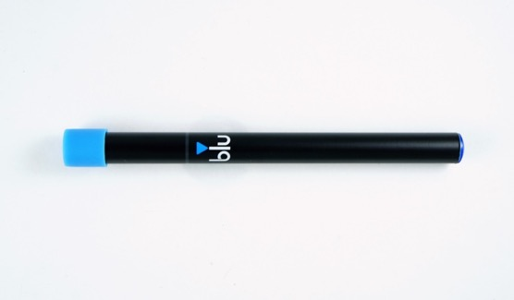

Blu_2
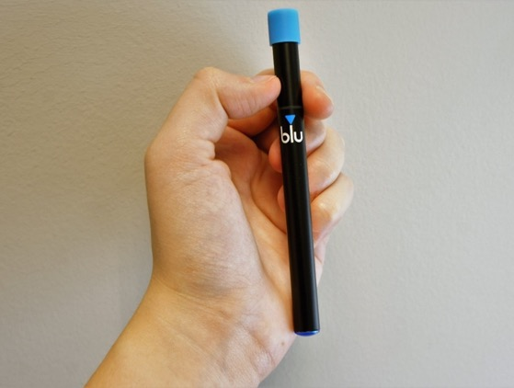

NJOY_1
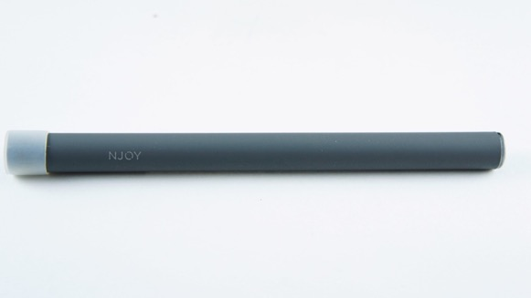

NJOY_2
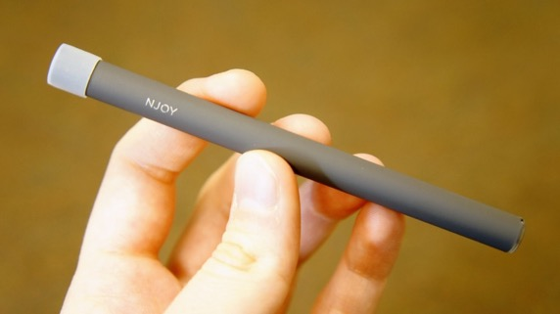

G6_1
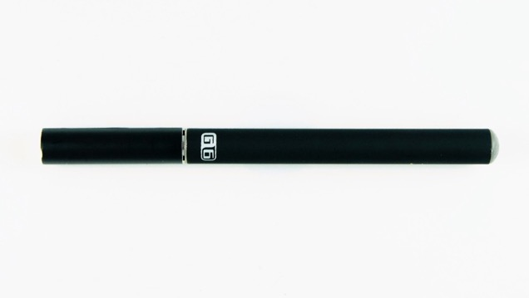

VuseVibe_1
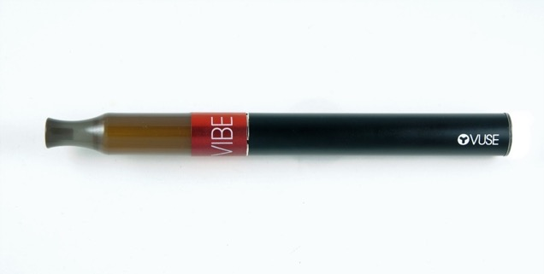

VuseVibe_2
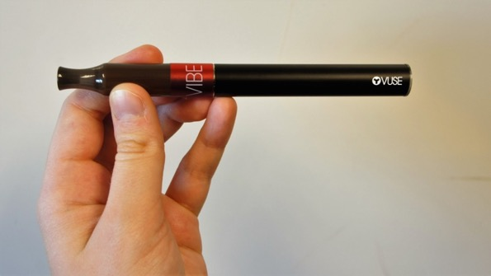

JUUL_1
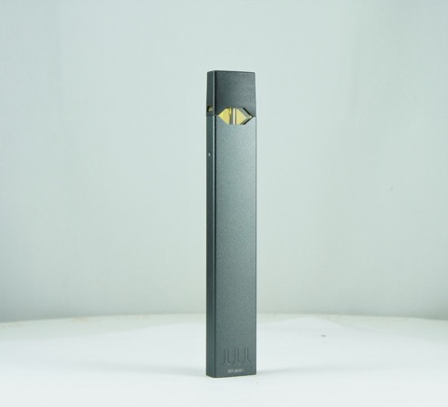

JUUL_2
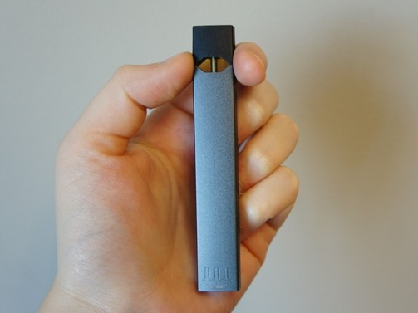

JUUL_Cartridge
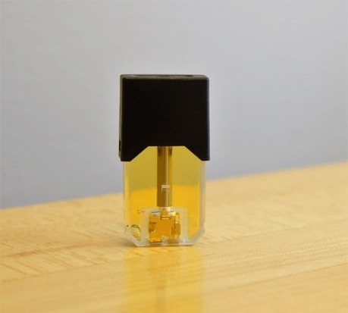

JUUL_Cartridge_2
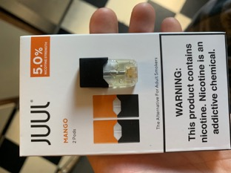

Smok_1
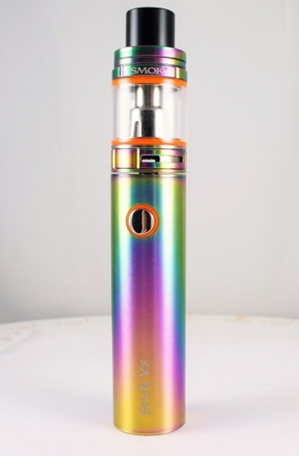

Smok_2
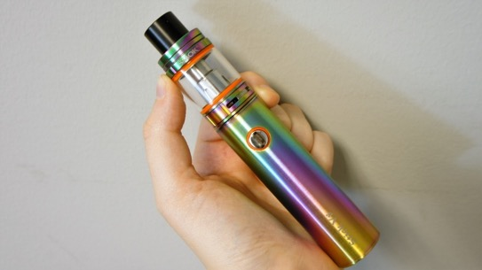

InnokinDV_1
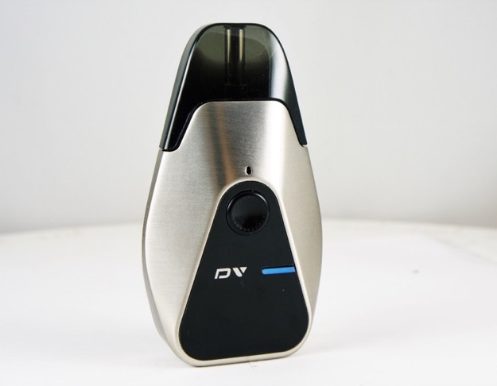
InnokinDV_2
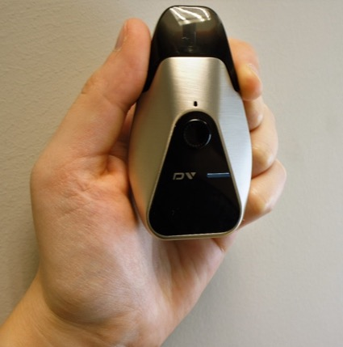

InnokinDV_Display
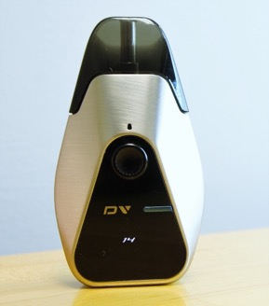

VaporessoLuxeS_1
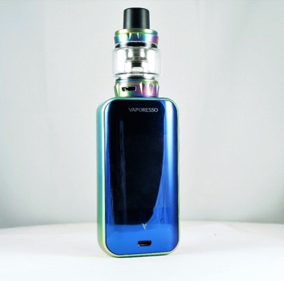

VaporessoLuxeS_2
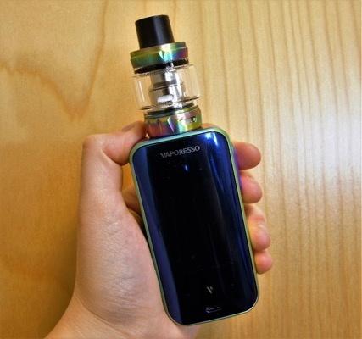

VaporessoLuxeS_Display_1
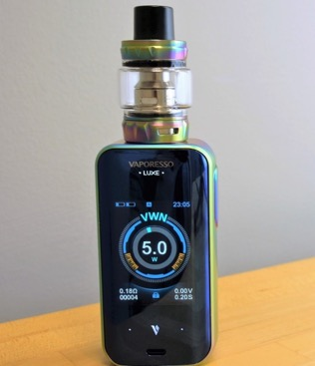

HaloLiquid
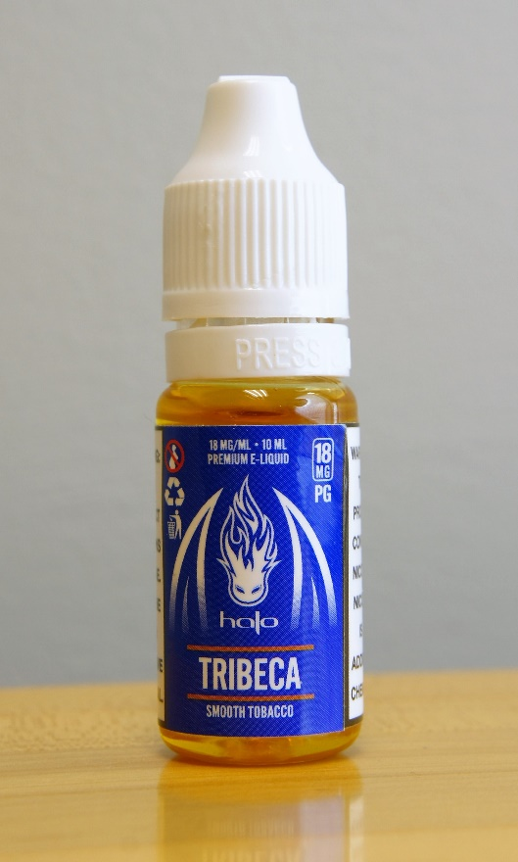

HaloLiquid_LabelOpen_2
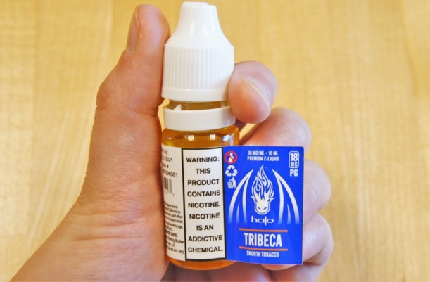

Puffbar_1
Puffbar_2

VaporessoLuxeS_watt
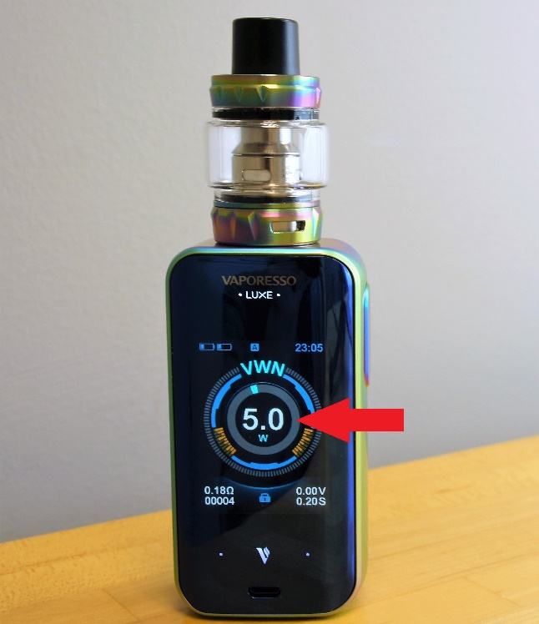

VaporessoLuxeS_volt
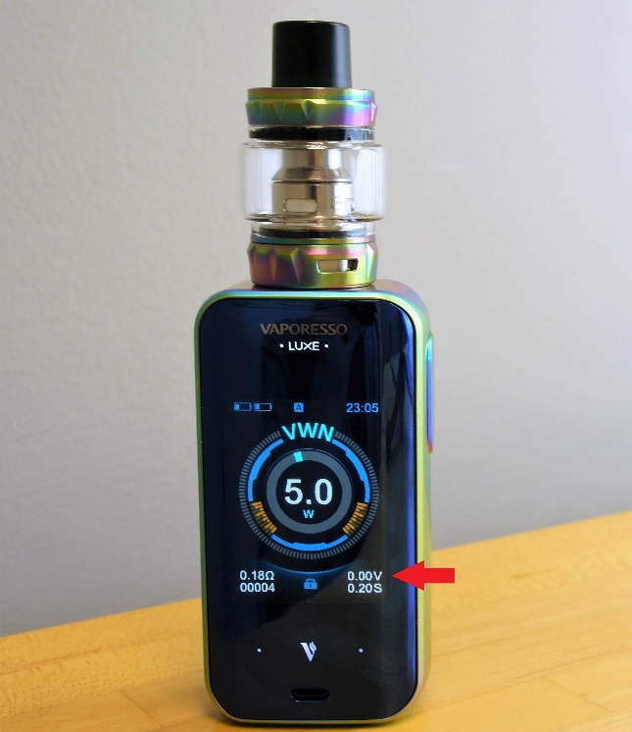

VaporessoLuxeS_ohm
