First page for participants who registered and clicked the personal secure link to the survey:

Thank you for confirming your phone number and welcome to the VAPER Study!

Click [insert appropriate name of button] to determine if you are eligible to participate.

New page:

“As a reminder, any perceived attempt to speed through the survey, take the survey more than once, or provide false or misleading information will result in your disqualification from the survey and forfeiture of any promised incentives.”]

New page:

Screening Questions:

- How old are you?
  - <18…ineligible
  - 18-20…ineligible
  - 21-24
  - 25-29
  - 30-34
  - 35-39
  - 40-44
  - 45-49
  - 50-54
  - 55-59
  - 60-64
  - 65-69
  - 70+

- Have you smoked a cigarette in the past 30 days?
  - Yes…next Q
  - No…skip to instruction page

- How many days in a typical week do you smoke cigarettes?
  - I do not smoke cigarettes in a typical week…next page
  - 1 day… next page
  - 2 days… next page
  - 3 days… next page
  - 4 days… next page
  - 5 days… next page
  - 6 days… next page
  - 7 days… next page

[Instruction]: “The next questions are about e-cigarettes or vaping devices.

There are many types of e-cigarettes or vaping devices. All are battery powered and produce vapor instead of smoke. E-cigarettes or vaping devices can be bought as one-time, disposable products, whereas other devices are re-usable.

Some re-usable devices have a tank that can be refilled with e-liquid (also called e-juice, PG juice, and vape juice), THC and CBD concentrates (also called waxes, oils, shatter, and dabs), herbs such as marijuana, and other substances. Other re-usable devices have replaceable cartridges or pods that contain the vaporized substance. Some of these cartridges or pods may be pre-filled and discarded after use, whereas, other cartridges and pods may be refillable.

Disposable e-cigarettes, pre-filled cartridges or pods, and bottles with e-liquids/oils for refillable devices come in many different flavors. Some people customize their own flavor blends by mixing their own flavors or having a vape shop mix their flavors.

Some common brands include JUUL, SMOK, Kandypens, and Grenco Science.

Here are a few examples of e-cigarettes or vaping devices. [DISPLAY ’Blu_1’; ‘NJOY_1’; ‘G6_1’; ‘VuseVibe_1’; ‘JUUL_1’; ‘Smok_1’; ‘InnokinDV_1’; ‘PuffBar_1’; and/or ‘VaporessoLuxeS_1’]”
- Have you used an e-cigarette or vaping device to vape THC concentrates, such as waxes, oils, shatter, and/or dabs, in the past 30 days?
  - Yes…next Q
  - No…skip to Q6

- How many days in a typical week do you use an e-cigarette or vaping device to vape THC concentrates?
  - I do not use an e-cigarette or vaping device to vape THC concentrates in a typical week…next Q
  - 1 day…next Q
  - 2 days…next Q
  - 3 days…next Q
  - 4 days…next Q
  - 5 days…next Q
  - 6 days…next Q
  - 7 days…next Q

- Have you used an e-cigarette or vaping device to vape CBD concentrates, such as waxes, oils, shatter, and/or dabs, in the past 30 days?
  - Yes…next Q
  - No…skip to Q8

- How many days in a typical week do you use an e-cigarette or vaping device to vape CBD concentrates?
  - I do not use an e-cigarette or vaping device to vape CBD concentrates in a typical week… next Q
  - 1 day… next Q
  - 2 days… next Q
  - 3 days… next Q
  - 4 days… next Q
  - 5 days…next Q
  - 6 days…next Q
  - 7 days…next Q

- Have you used an e-cigarette or vaping device to vape e-liquids with or without nicotine in the past 30 days?
  - Yes…next Q
  - No…ineligible…skip to ineligible screen

- How many days in a typical week do you use an e-cigarette or vaping device to vape e-liquids with or without nicotine?
  - I do not use an e-cigarette or vaping device to vape e-liquids with or without nicotine in a typical week…ineligible…skip to ineligible screen
  - 1 day…ineligible…skip to ineligible screen
  - 2 days…ineligible…skip to ineligible screen
  - 3 days…ineligible…skip to ineligible screen
  - 4 days…ineligible…skip to ineligible screen
  - 5 days…eligible
  - 6 days…eligible
  - 7 days…eligible

E-cig only users:

Q8: Yes
Q9 : 5-7 days

Dual users:

Q8: Yes
Q9 : 5-7 days
And
Q2: Yes
Q3 : 5-7 days

Questionnaire:

[Instruction (new page)]: Unless otherwise stated, all questions hereafter are in reference to e-cigarettes or vaping devices used to consume e-liquid (also called e-juice, PG juice, and vape juice), which may or may not contain nicotine. They are NOT in reference to use of THC, CBD, marijuana, or other substances.
I acknowledge that I have carefully read and understand the paragraph above.
- Yes
- Are you…?
  - Male
  - Female
  - Other Please specify your gender: _________
  - Prefer not to answer

- Approximately how old were you when you first tried an e-cigarette or vaping device?
  - [Open ended – enter number only]

- Please select the reasons that you tried an e-cigarette or vaping device for the first time:
  - Curiosity (Yes/No)
  - To try the flavor(s) (Yes/No)
  - Use by friends (Yes/No)
  - Absence of smell (Yes/No)
  - For use where smoking is banned (Yes/No)
  - To quit or cut down on smoking (Yes/No)
  - Some other reason (Yes/No) Please specify: _______________

***Measure was modified during the wave from a grid style to a check all the apply style. The new question stem was modified to “Please select the reasons that you tried an e-cigarette or vaping device for the first time: (Check all that apply)”***

- What is your PRIMARY reason for CONTINUING to use an e-cigarette or vaping device?
  - To quit smoking
  - To cut down smoking
  - To use when I am not allowed to smoke
  - Absence of smell
  - To socialize
  - To have a longer break at work
  - Because I enjoy the flavor
  - Because I enjoy the boost
  - Curiosity/just want to try them
  - Some other reason Please specify: _______________

[Instruction]: “Thinking about your most used device, please answer the following questions.”

- What is the brand AND model of the device (e.g., JUUL, Vaporesso Luxe, Voopoo Drag 2, etc.)?
  - Open ended response

- How did you buy the device?
  - In person
  - From the internet
  - Some other means Please specify______________
  - I did not buy the e-cig or vaping device

- [If Q6 is ‘a’]: Where did you buy the device?
  - A mall kiosk
  - A convenience store or gas station
  - A supermarket or grocery store
  - A drug store
  - A warehouse club, such as Sam’s or Costco
  - A vape shop
  - A marijuana dispensary or retailer
  - A smoke shop, tobacco specialty store, or tobacco outlet store
  - A duty-free shop or military commissary
  - A bar, pub, restaurant, or casino
  - A friend or relative
  - A swap meet or flea market
  - A liquor store
  - Somewhere else Please specify__________

- Is the device…
  - Re-usable (i.e., you recharge the device when the battery life is low or at 0%)
  - Disposable (i.e., you discard entire device when the battery life is low or at 0%)

- [If ‘a’ is selected in Q8]: Does the device have SETTINGS that allow you to modify power or vapor volume?
  - Yes
  - No

- [If ‘a’ is selected in Q8]: Does the device have a VISUAL DISPLAY that allows you to see the wattage or other vape settings?
  - Yes
  - No

- [If ‘a’ is selected in Q8]: Can you modify or replace the device’s tank or coil?
  - Tank (Yes/No/Don’t know)
  - Coil (Yes/No/Don’t know)

- [If ‘yes’ is selected for tank in Q11]: Have you modified or replaced the device’s TANK?
  - Yes
  - No

- [If ‘a’ is selected in Q12]: Do you know the brand AND model of your device’s modified or replaced TANK?
  - Yes Please specify the brand and model________
  - No

- [If ‘yes’ is selected for coil in Q11]: Have you modified or replaced the device’s COIL?
  - Yes
  - No

- [If ‘a’ is selected in Q14]: Do you know the brand AND model of your device’s modified or replaced COIL?
  - Yes Please specify the brand and model_______
  - No

- [If ‘a’ is selected in Q8]: When the device runs out of e-liquid, do you TYPICALLY…
  - Discard the empty cartridge or pod and replace with a new and unused cartridge or pod prefilled with e-liquid
  - Refill the empty tank/cartridge/pod with e-liquid from a larger container(s) of e-liquid

- Please select the answer that is NOT a fruit:
  - Apple
  - Banana
  - Pineapple
  - Chair
  - Mango

[If ‘A’ is selected in Q16…Continue to prompt before Q18-26]
[If ‘B’ is selected in Q16…Skip to prompt before Q30-55]
[If ‘B’ is selected in Q8…Skip to prompt before Q59-63]

[Instructions for Q18-27]: “Thinking about your most used e-liquid in a cartridge or pod for your most used device only, please answer the following questions.”

- [If ‘a’ is selected in Q16]: Do you know the brand of the cartridge or pod (e.g., JUUL, blu, VUSE, etc.)?
  - Yes Please specify the brand______
  - No

- [If ‘a’ is selected in Q16]: What is the flavor of the e-liquid?
  - Tobacco
  - Tobacco menthol or menthol
  - Mint
  - A flavor like fruit, candy, alcohol, coffee, vanilla, or other food/drink Please specify the flavor ________
  - No flavor

- [If ‘a’ is selected in Q16]: Do you know how much nicotine is in the e-liquid?
  - Yes, I know the mg of nicotine Please specify_______
  - Yes, I know the % of nicotine Please specify_______
  - No

- [If ‘a’ is selected in Q16]: Does the e-liquid contain nicotine salts?
  - Yes
  - No
  - Don’t know

- [If ‘a’ is selected in Q16]: How did you last buy the cartridge or pod?
  - In person
  - From the internet
  - Some other means Please specify_____________
  - I did not buy the e-liquid

- [If Q22 is ‘a’]: Where did you last buy the cartridge or pod?
  - A mall kiosk
  - A convenience store or gas station
  - A supermarket or grocery store
  - A drug store
  - A warehouse club, such as Sam’s or Costco
  - A vape shop
  - A marijuana dispensary or retailer
  - A smoke shop, tobacco specialty store, or tobacco outlet store
  - A duty-free shop or military commissary
  - A bar, pub, restaurant, or casino
  - A friend or relative
  - A swap meet or flea market
  - A liquor store
  - Somewhere else Please specify__________

- [If ‘a’ is selected in Q16]: Approximately how many days does it take for you to finish your most used cartridge or pod?
  - Less than one day
  - At least one day Please specify the number of days_______
  - Don’t know

- [If ‘a’ is selected in Q16]: Thinking about your cartridges or pods for your most used device only…Approximately how many different flavors did you vape in the past week?
  - [Open ended – enter number only]

- [If ‘a’ is selected in Q16]: Still thinking about your cartridge or pods for your most used device only…What flavor do you use SECOND MOST OFTEN?
  - Tobacco
  - Tobacco menthol or menthol
  - Mint
  - A flavor like fruit, candy, alcohol, coffee, vanilla, or other food/drink Please specify the flavor________
  - No flavor
  - None of the above because I use only one flavor

[Instruction for Q27-29]: “Please take a moment to get your most used device and your most used cartridge/pod for the device. The next 2-3 prompts will ask you to upload PHOTOS of each.

DO NOT UPLOAD PHOTOS YOU FOUND ON THE INTERNET OR PHOTOS THAT CAN BE USED TO IDENTIFY YOU OR ANOTHER PERSON.”

- [If ‘a’ is selected in Q16]: Please take a picture of your most used device with the brand information clearly visible.

Here is an (are) example(s) of the photo you should take. [DISPLAY ‘JUUL_2’ and/or ‘VuseVibe_2’]

- [If ‘a’ is selected in Q16 and Q10 is ‘Yes’]: Please take a picture of your most used device's visual display when it shows information about your current vape settings.

Here is an (are) example photo(s). [DISPLAY ‘InnokinDV_Display’ and/or ‘VaporessoLuxeS_Display_1’]

- [If ‘a’ is selected in Q16]: Please take a PHOTO of your most used cartridge or pod for your most used device. If on the cartridge or pod, the photo should clearly show the brand, flavor, and mg or percent of nicotine.

Here is an example of the photo you should take. [DISPLAY ‘JUUL_Cartridge’ and/or ‘JUUL_Cartridge_2’]

[skip to Q65]

[Instructions for Q30-55]: “Thinking about your most used e-liquid for your most used device only, please answer the following questions.”

- [If ‘b’ is selected in Q16]: Is your most used e-liquid a…
  - Customized flavor blend – mixed yourself
  - Customized flavor blend – mixed for you by someone else
  - Non-customized flavor

- [If ‘c’ is selected in Q30]: Do you know the brand on the e-liquid container (e.g., Naked 100, Beard Vape, Milkman, etc.)?
  - Yes Please specify the brand_________
  - No

- [If ‘c’ is selected in Q30]: What is the flavor of the e-liquid?
  - Tobacco
  - Tobacco menthol or menthol
  - Mint
  - A flavor like fruit, candy, alcohol, coffee, vanilla, or other food/drink Please specify the flavor________
  - No flavor

- [If ‘c’ is selected in Q30]: Do you know how much nicotine is in the e-liquid?
  - Yes, I know the mg of nicotine Please specify_______
  - Yes, I know the % of nicotine Please specify_______
  - No

- [If ‘c’ is selected in Q30]: Does the e-liquid contain nicotine salts?
  - Yes
  - No
  - Don’t know

- [If ‘c’ is selected in Q30]: How did you last buy the e-liquid?
  - In person
  - From the internet
  - Some other means Please specify_____________
  - I did not buy the e-liquid

- [If ‘a’ is selected in Q35]: Where did you last buy the e-liquid?
  - A mall kiosk
  - A convenience store or gas station
  - A supermarket or grocery store
  - A drug store
  - A warehouse club, such as Sam’s or Costco
  - A vape shop
  - A marijuana dispensary or retailer
  - A smoke shop, tobacco specialty store, or tobacco outlet store
  - A duty-free shop or military commissary
  - A bar, pub, restaurant, or casino
  - A friend or relative
  - A swap meet or flea market
  - A liquor store
  - Somewhere else Please specify__________

- [If ‘c’ is selected in Q30]: Do you know the bottle size (in milliliters) of your most used e-liquid that you last purchased?
  - Yes Please specify the bottle size (in mL) ______
  - No

- [If ‘c’ is selected in Q30]: Approximately how many days does it take for you to finish your most used e-liquid container?
  - Less than one day
  - At least one day Please specify the number of days_______
  - Don’t know

- [If ‘c’ is selected in Q30]: Thinking about your most used device only…Approximately how many different customized flavor blends – flavors you mixed yourself or mixed for you by someone else – did you vape in the past week?
  - [Open ended – enter number only]

- [If Q39 is greater than zero]: Did you mix any of the customized flavor blends yourself in the past week?
  - Yes
  - No

- [If ‘c’ is selected in Q30]: Still thinking about your most used device only…Approximately how many different non-customized flavors did you vape in the past week?
  - [Open ended – enter number only]

- [If ‘c’ is selected in Q30]: Again thinking about your most used device only…What flavor do you use SECOND MOST OFTEN?
  - Tobacco
  - Tobacco menthol or menthol
  - Mint
  - A customized flavor blend Please specify the flavor________
  - A non-customized flavor like fruit, candy, alcohol, coffee, vanilla, or other food/drink Please specify the flavor________
  - No flavor
  - None of the above because I use only one flavor

[Skip to prompt before Q56]

- [If ‘a’ or ‘b’ is selected in Q30]: How would you describe the flavor blend (e.g., Strawberry and mint)?
  - [Open ended]

- [If ‘a’ or ‘b’ is selected in Q30]: Do you know how much nicotine is in the flavor blend?
  - Yes, I know the mg of nicotine Please specify_______
  - Yes, I know the % of nicotine Please specify_______
  - No

- [If ‘a’ or ‘b’ is selected in Q30]: Does the flavor blend contain nicotine salts?
  - Yes
  - No
  - Don’t know

- [If ‘a’ is selected in Q30]: How did you last buy the e-liquids needed to make the flavor blend?
  - In person (Yes/No)
  - From the internet (Yes/No)
  - Some other means (Yes/No) --> Please specify_____________
  - I did not buy all of e-liquids (Yes/No)

***Measure was modified during the wave from a grid style to a check all the apply style. The new question stem was modified to “How did you last buy the e-liquids needed to make the flavor blend? (Check all that apply.)”***

- [If ‘a’ is selected in Q46]: Where did you last buy the e-liquids to make the flavor blend?
  - A mall kiosk (Yes/No)
  - A convenience store or gas station (Yes/No)
  - A supermarket or grocery store (Yes/No)
  - A drug store (Yes/No)
  - A warehouse club, such as Sam’s or Costco (Yes/No)
  - A vape shop (Yes/No)
  - A marijuana dispensary or retailer (Yes/No)
  - A smoke shop, tobacco specialty store, or tobacco outlet store (Yes/No)
  - A duty-free shop or military commissary (Yes/No)
  - A bar, pub, restaurant, or casino (Yes/No)
  - A friend or relative (Yes/No)
  - A swap meet or flea market (Yes/No)
  - A liquor store (Yes/No)
  - Somewhere else (Yes/No) --> Please specify__________

***Measure was modified during the wave from a grid style to a check all the apply style. The new question stem was modified to “Where did you last buy the e-liquids to make the flavor blend? (Check all that apply.)”***

- [If ‘b’ is selected in Q30]: How did you last buy the flavor blend?
  - In person
  - From the internet
  - Some other means --> Please specify_____________
  - I did not buy the flavor blend

- [If ‘a’ is selected in Q48]: Where did you last buy the flavor blend?
  - A mall kiosk
  - A convenience store or gas station
  - A supermarket or grocery store
  - A drug store
  - A warehouse club, such as Sam’s or Costco
  - A vape shop
  - A marijuana dispensary or retailer
  - A smoke shop, tobacco specialty store, or tobacco outlet store
  - A duty-free shop or military commissary
  - A bar, pub, restaurant, or casino
  - A friend or relative
  - A swap meet or flea market
  - A liquor store
  - Somewhere else --> Please specify_______

- [If ‘a’ or ‘b’ is selected in Q30]: Do you know the bottle size (in milliliters) of your most used flavor blend?
  - Yes Please specify the bottle size (in mL) ______
  - No

- [If ‘a’ or ‘b’ is selected in Q30]: Approximately how many days does it take for you to finish the e-liquid container with your most used flavor blend?
  - Less than one day
  - At least one day --> Please specify the number of days_______
  - Don’t know

- [If ‘a’ or ‘b’ is selected in Q30]: Thinking about your most used device only…Approximately how many different customized flavor blends – flavors you mixed yourself or mixed for you by someone else – did you vape in the past week?
  - [Open ended – enter number only]

- [If ‘b’ is selected in Q30 and Q52 is greater than zero]: Did you mix any of the customized flavor blends yourself in the past week?
  - Yes
  - No

- [If ‘a’ or ‘b’ is selected in Q30]: Still thinking about your most used device only…Approximately how many different non-customized flavors did you vape in the past week?
  - [Open ended – enter number only]

- [If ‘a’ or ‘b’ is selected in Q30]: Again thinking about your most used device only…What flavor do you use SECOND MOST OFTEN?
  - Tobacco
  - Tobacco menthol or menthol
  - Mint
  - A customized flavor blend --> Please specify the flavor________
  - A non-customized flavor like fruit, candy, alcohol, coffee, vanilla, or other food/drink Please specify the flavor________
  - No flavor
  - None of the above because I use only one flavor

[Instruction for Q56-58]: “Please take a moment to get your most used device and your most used e-liquid container for the device. The next 2-3 prompts will ask you to upload PHOTOS of each.

DO NOT UPLOAD PHOTOS YOU FOUND ON THE INTERNET OR PHOTOS THAT CAN BE USED TO IDENTIFY YOU OR ANOTHER PERSON.”

- [If ‘b’ is selected in Q16]: Please take a picture of your most used device with the brand information clearly visible.

Here is an (are) example(s) of the photo you should take. [DISPLAY ‘VaporessoLuxeS_2’ and/or ‘Smok_2’]

- [If ‘b’ is selected in Q16 and Q10 is ‘Yes’]: Please take a picture of your most used device's visual display when it shows information about your current vape settings.

Here is an (are) example photo(s). [DISPLAY ‘InnokinDV_Display’ and/or ‘VaporessoLuxeS_Display_1’]

- [If ‘b’ is selected in Q16]: Please take a PHOTO of your most used e-liquid container for your most used device. If on the e-liquid container, the photo should clearly show the brand, flavor, and mg or percent of nicotine.

Here is an example of the photo you should take. [DISPLAY ‘HaloLiquid_LabelOpen_2]

[skip to Q65]

[Instructions for Q59-63] “Thinking about the e-liquid in your most used disposable device only, please answer the following questions.”

- [If ‘b’ is selected in Q8]: What is the flavor of the device’s e-liquid?
  - Tobacco
  - Tobacco menthol or menthol
  - Mint
  - A flavor like fruit, candy, alcohol, coffee, vanilla, or other food/drink Please specify the flavor________
  - No flavor

- [If ‘b’ is selected in Q8]: Do you know how much nicotine is in the device’s e-liquid?
  - Yes, I know the mg of nicotine --> Please specify_______
  - Yes, I know the % of nicotine --> Please specify_______
  - No

- [If ‘b’ is selected in Q8]: Does the device’s e-liquid contain nicotine salts?
  - Yes
  - No
  - Don’t know

- [If ‘b’ is selected in Q8]: Still thinking about your most used disposable devices only…Approximately how many of these devices do you vape each week?
  - Less than one full disposable device
  - At least one full disposable device --> Please specify the number _______
  - Don’t know

- [If ‘b’ is selected in Q8]: Again thinking about your most used disposable devices only…What flavor do you use SECOND MOST OFTEN?
  - Tobacco
  - Tobacco menthol or menthol
  - Mint
  - A flavor like fruit, candy, alcohol, coffee, vanilla, or other food/drink --> Please specify the flavor________
  - No flavor
  - None of the above because I use only one flavor

[Instruction for Q64]: “Please take a moment to get your most used disposable device. The next prompt will ask you to upload a PHOTO of your device.

DO NOT UPLOAD PHOTOS YOU FOUND ON THE INTERNET OR PHOTOS THAT CAN BE USED TO IDENTIFY YOU OR ANOTHER PERSON.”

- [If ‘b’ is selected in Q8]: Please take a picture of your most used disposable device with the brand information clearly visible.

Here is an (are) example(s) of the photo you should take. [DISPLAY ‘Blu_2’, ‘Puffbar_2’, and/or; ‘NJOY_2’]

[continue to Q65]

- Compared to smoking cigarettes, how addictive do you think vaping (using e-cigarettes or vaping devices) with nicotine is?
  - Much less addictive than smoking cigarettes
  - Somewhat less addictive than smoking cigarettes
  - Equally addictive to smoking cigarettes
  - Somewhat more addictive than smoking cigarettes
  - Much more addictive than smoking cigarettes

- Compared to smoking cigarettes, how harmful to your health do you think vaping (using e-cigarettes or vaping devices) is?
  - Much less harmful than smoking cigarettes
  - Somewhat less harmful than smoking cigarettes
  - Equally harmful to smoking cigarettes
  - Somewhat more harmful than smoking cigarettes
  - Much more harmful than smoking cigarettes

- Please select the third answer choice to continue to the next question:
  - One
  - Two
  - Three
  - Four
  - Five

- Are you planning to quit vaping:
  - Within the next month
  - Between 1-6 months from now
  - Sometime in the future, beyond 6 months
  - Not planning to quit
Please respond to each question or statement by marking the most appropriate response.
 | Almost Always | Often | Sometimes | Rarely | Never
69. I find myself reaching for my e-cigarette without thinking about it. | ( 4 ) | ( 3 ) | ( 2 ) | ( 1 ) | ( 0 )
70. I drop everything to go out and buy e-cigarettes or e-juice. | ( 4 ) | ( 3 ) | ( 2 ) | ( 1 ) | ( 0 )
71. I vape more before going into a situation where vaping is not allowed. | ( 4 ) | ( 3 ) | ( 2 ) | ( 1 ) | ( 0 )
72. When I haven’t been able to vape for a few hours, the craving gets intolerable. | ( 4 ) | ( 3 ) | ( 2 ) | ( 1 ) | ( 0 )

Instruction: The following questions are about your CIGARETTE use only.

 | Always | Often | Sometimes | Rarely | Never
73. [Dual]: When I haven’t been able to smoke for a few hours, the craving gets intolerable. | ( 4 ) | ( 3 ) | ( 2 ) | ( 1 ) | ( 0 )
74. [Dual]: I find myself reaching for cigarettes without thinking about it. | ( 4 ) | ( 3 ) | ( 2 ) | ( 1 ) | ( 0 )
75. [Dual]: I drop everything to go out and buy cigarettes. | ( 4 ) | ( 3 ) | ( 2 ) | ( 1 ) | ( 0 )
76. [Dual]: I smoke more before going into a situation where smoking is not allowed. | ( 4 ) | ( 3 ) | ( 2 ) | ( 1 ) | ( 0 )

- [Dual]: Approximately how old were you when you first tried a cigarette?
  - [Open ended – enter number only]

- [Dual]: Are you planning to quit smoking cigarettes?
  - Within the next month
  - Between 1-6 months from now
  - Sometime in the future, beyond 6 months
  - Not planning to quit

[Instruction]: This is a scale that asks you to rate the difficulty of your breathing. It starts at number 0 (no difficulty breathing at all) and progresses through to number 10 (your breathing is extremely difficult)

- How much difficulty does your breathing cause you typically?
  - 0 (no difficulty breathing at all]
  - 1
  - 2
  - 3
  - 4
  - 5
  - 6
  - 7
  - 8
  - 9
  - 10 (breathing is extremely difficult]

- Over the past 3 months, you had shortness of breath:
  - Most days of the week
  - Several days a week
  - A few days a month
  - Only with chest infections
  - Not at all

- Which, if any, of the following products have you used or tried in the past 30 days?
  - Traditional cigars (like Macanudo, Romeo y Julieta, or Arturo Fuente) (Used/Tried v. Did not use/try)
  - Pipe (with tobacco) (Used/Tried v. Did not use/try)
  - Cigarillos/filtered cigars (like Black & Mild, Swisher Sweets, or Phillies Blunt) (Used/Tried v. Did not use/try)
  - Chewing tobacco or dip/snuff/snus (like Levi Garrett, Red Man, or Beech Nut, Skoal or Copenhagen) (Used/Tried v. Did not use/try)
  - Hookah/shisha (like hookah tobacco) (Used/Tried v. Did not use/try)
  - Nicotine replacement products (like gum, patches, lozenges) (Used/Tried v. Did not use/try)
  - Marijuana (i.e., dry herb) (Used/Tried v. Did not use/try)

***Measure was modified during the wave from a grid style to a check all the apply style. The new question stem was modified to “Which, if any, of the following products have you used or tried in the past 30 days? (Check all that apply.)”***

- How many days in a typical week do you use [product(s) selected in Q81]?
  - I do not use [product(s) selected in Q81] in a typical week
  - 1 day
  - 2 days
  - 3 days
  - 4 days
  - 5 days
  - 6 days
  - 7 days

- Do you consider yourself to be Hispanic, Latino, or of Spanish origin?
  - Yes
  - No
  - Prefer not to answer

- [If yes to Q83]: Do you consider yourself…
  - Puerto Rican (Yes/No)
  - Cuban (Yes/No)
  - Mexican (Yes/No)
  - Central or South American (Yes/No)

- What race or races do you consider yourself to be?
  - American Indian or Alaska Native (Yes/No/Prefer not to answer)
  - Asian or Asian American (Yes/No/Prefer not to answer)
  - Black or African American (Yes/No/Prefer not to answer)
  - Native Hawaiian or Pacific Islander (Yes/No/Prefer not to answer)
  - White (Yes/No/Prefer not to answer)
  - Other (Yes/No/Prefer not to answer)

- [Annual]: What is your best estimate of the total annual household income from all sources, before taxes, in [last calendar year in 4-digit format]? [Drop down options preferable to multiple choice]
  - $0 – $19,999
  - $20,000 – $39,999
  - $40,000 – $59,999
  - $60,000 – $79,999
  - $80,000 – $99,999
  - $100,000 – $119,999
  - $120,000 – $139,999
  - $140,000 – $159,999
  - $160,000 – $179,999
  - $180,000 – $199,999
  - $200,000+
  - Prefer not to answer

- Please select the location where you heard about the VAPER Study.
  - Vape shop
  - Friend
  - Social media
  - Craigslist
  - Other --> Please specify ________

- [If ‘Vape shop’ is selected in Q87] I first learned about the VAPER Study from a vape shop located in ________.
  - [List all cities in our catchment area]

- [If ‘city’ is selected in Q87] The name of the vape shop was ________.
  - [List all vape shops in the city that are part of the catchment area]

New page:

Thank you for completing the survey! You may now choose to submit or discard your survey. If you submit the survey and later decide to withdraw your survey, please email vaper@vcu.edu or call us at 1-800-304-9402.

<Submit> <Discard>

New page:

[If discarded]: Thank you. Your information will not be used by the study team.

New page:

[If submitted]: We would like to ask you similar questions in the future and provide you with a $10 gift code for each survey you complete. Are you interested in participating in our future e-cigarette surveys?

<Yes> <No>

New page:

[Assuming we have lab visits as part of our study, if submitted and ‘Yes’ is selected]: A select group of survey participants will have the opportunity to enroll in laboratory visit(s) at [USC/OSU/VCU]. Those who qualify and complete the lab visits will receive $75 in cash for each annual visit. The laboratory visit would require you to bring your e-cigarette and e-liquid to the lab and use your device as you normally would for 25 minutes. Are you interested in participating in a future lab visit?

<Yes> <No>

New page:

[Assuming we have lab visits as part of our study, if submitted and ‘Yes’ x 2 is selected]: The laboratory is located at this address: [123 Main Street, Los Angeles, CA 43210]. Are you able and willing to transport yourself to this location on a future date you may be available? You are not expected to schedule the visit at this time.

<Yes> <No>

New page:

To notify you about future surveys [if ‘Yes has been answered for both lab questions: “and lab visits” should be added assuming we have lab visits as part of our study] we will contact you using the cell phone number and email address provided prior to taking the survey.

New page:

We would like to continually improve this survey. If you have any comments or suggestions about this survey, please provide them here.

<open ended response>

New page:

After we have reviewed your registration form and questionnaire and verified your submission is valid, we will mail you your $10 Amazon gift code within [timeframe].

Only one individual per mailing address is eligible to receive the incentive and if multiple individuals from the same address respond to the study, the incentive will only be sent once. We will not mail incentives to P.O. Boxes. We will send the incentive only once even if an individual responds to this survey more than once.

New page:

Thanks, again, for completing our questions. If you have any questions please contact us at vaper@vcu.edu or 1-800-304-9402.

Photos (Image names are above each image):

Blu_1
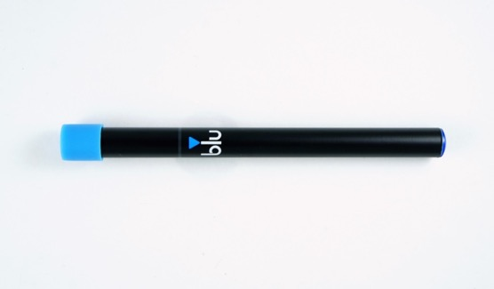

Blu_2
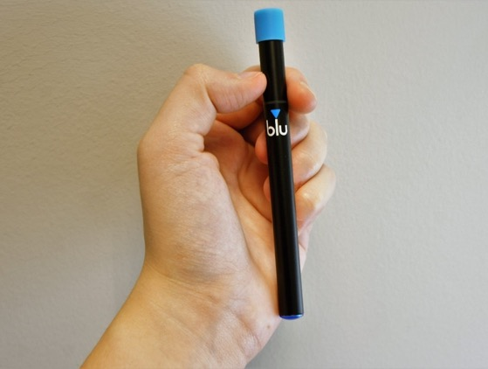

NJOY_1
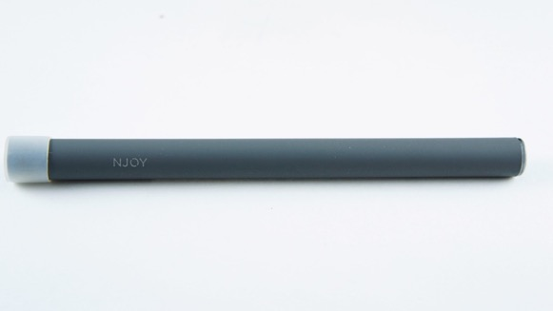

NJOY_2
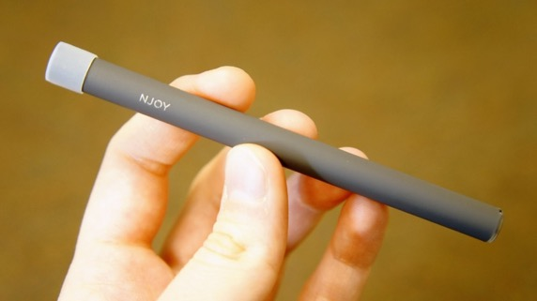

G6_1
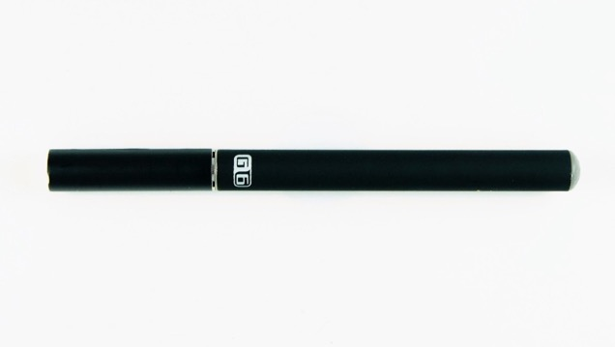

VuseVibe_1
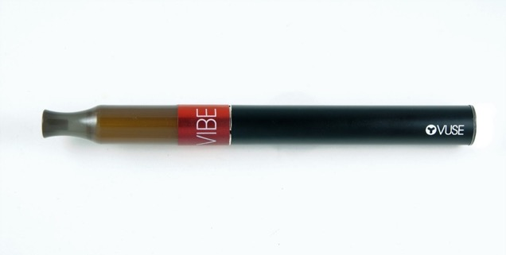

VuseVibe_2
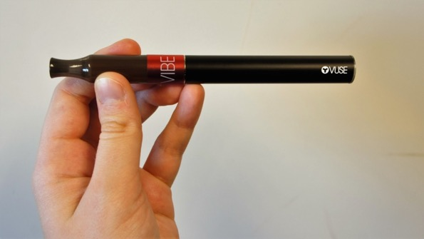

JUUL_1
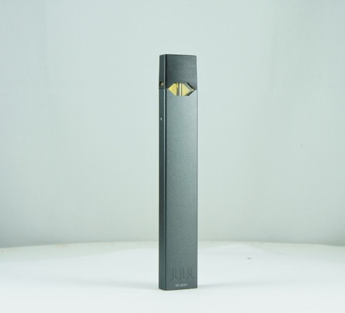

JUUL_2
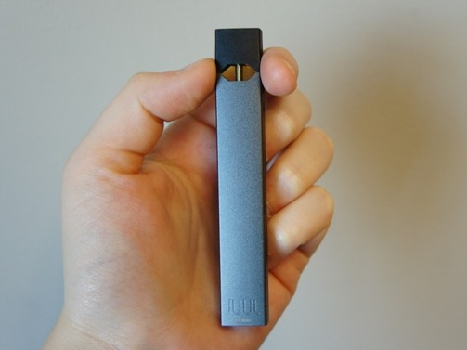

JUUL_Cartridge
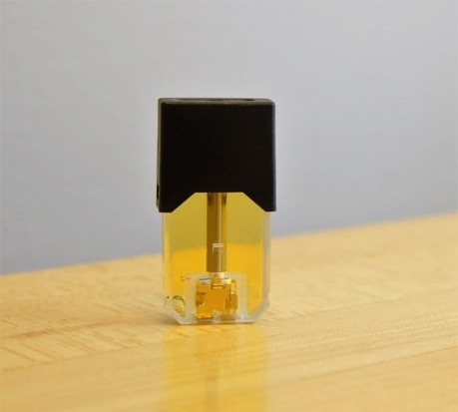

JUUL_Cartridge_2
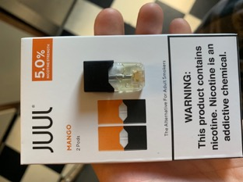
Smok_1
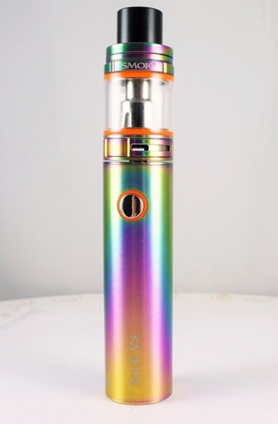

Smok_2
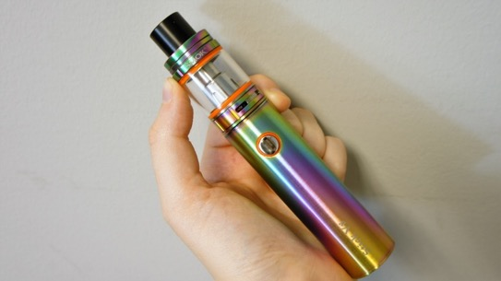
InnokinDV_1
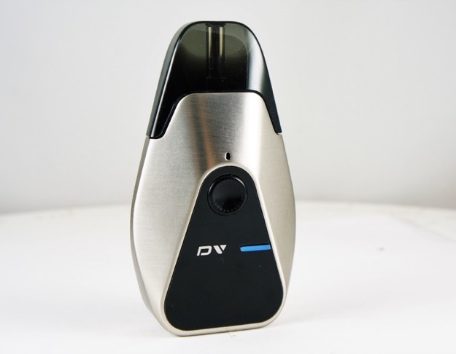
InnokinDV_2
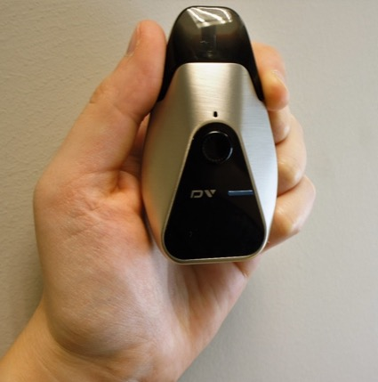

InnokinDV_Display
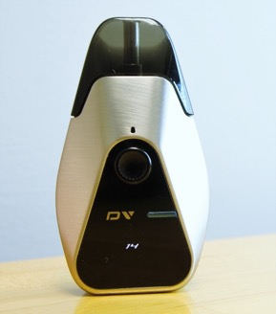

VaporessoLuxeS_1
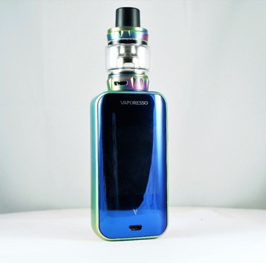

VaporessoLuxeS_2
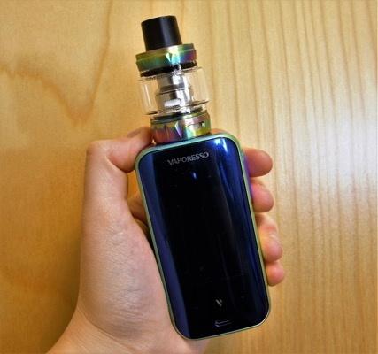

VaporessoLuxeS_Display_1
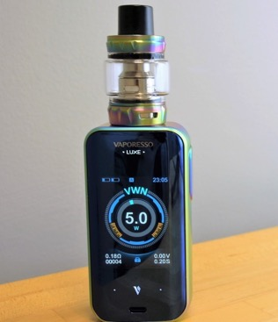

HaloLiquid_LabelOpen_2
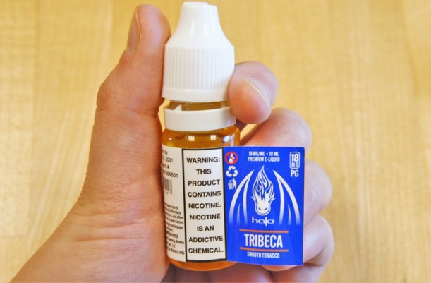

Puffbar_1
Puffbar_2

